Student Mental Health Signposting App (My Mind)
Alexander Edward Davis

A report submitted as part of the requirements for the degree of BSc in Computer Science at the School of Computing and Digital Technology
Birmingham City University, Birmingham, UK
May 2017
Supervisor Dr. Yevgeniya Kovalchuk

Abstract
The current mental health and wellbeing counselling service at Birmingham City University has experienced a 300% rise in referrals since 2011 causing a lot of strain on the ageing system that they currently use.
The condition and usability of the current system not only delays the process for a student to gain access to the counselling service, but it also discourages people who are looking to access the service due to the large unpopularity of the iASK system the university has implemented. The iASK system is unpopular due to the fact the system does not work most of the time and when it does, the information is not there or incomplete.
This has led to the counselling service to use a Microsoft SharePoint form to offer a referral service for students. The student is unable to access it due to the system requiring them to login, which is currently intermittent due to the university implementing a new single sign-on service, meaning students tend to give up on trying to access the service.
In this report, I have designed and created a basic framework within an app which the university can implement into their current iASK system, diverting most of the traffic away from the unfinished support portal and streamlining and updating the systems the student affairs team use.
To allow me to create the app, I have asked several students from across the university to participate in the design and evaluation of any product I produce within this project. I have also timed these students accessing the current referral form for the student affairs team.

Acknowledgements
Dr. Yevgeniya Kovalchuk has been an incredibly supportive thesis supervisor. Her insightful criticisms and patient encouragement aided the progress within this project in innumerable ways.
Fathia Warren has also provided her insightful knowledge as a support tutor within this project giving me the needed advice and suggestions to make my project successful and meet the expectations required for this thesis.

Dedication
This thesis is dedicated to my father, who sadly passed away in July 2016. It is also dedicated to Peter Bell and James Edwards, friends who always questioned my processes and pushed me to do the very best within my field.

Declaration

I confirm that the work contained in this BSc project report has been composed solely by myself and has not been accepted in any previous application for a degree. All sources of information have been specifically acknowledged and all verbatim extracts are distinguished by quotation marks.
Signed: Date: 16th May 2017
Alexander Edward Davis

Table of Contents
Abstract ii
Acknowledgements iii
Dedication iii
Declaration iv
Table of Contents v
List of Tables viii
List of Figures ix
Introduction 1
1.1 Background 1
1.1.1 Project Background 1
1.1.2 Aim 1
1.1.3 Objectives 1
1.1.4 Product 3
1.2 About this Thesis 3
1.2.1 Reasons for Project 3
1.2.2 Project Effects 4
1.2.3 Comparison of other possible solutions 4
1.3 Chapter List 4
Literature Review 6
2.1 Introduction 6
2.2 The Deployment of Mental Health Services 7
2.2.1 Mental Health Services in the United States of America 7
2.2.2 Mental Health Services in the United Kingdom 7
2.3 The Concept of Social Media 8
2.3.1 Different Types of Social Media Platform 8
2.3.2 The Uses of Social Media 8
2.4 The Use of Social Media Within Mental Health Services 9
2.4.1 Adoption within Education Institutions 10
2.5 Conclusion 10
Background Research 11
3.1 Research Subjects 11
3.2 Research Methods 11
3.2.1 Interviews 11
3.2.2 Analysis of Current System 12
3.3 Conclusion 13
Requirements 14
4.1 App Design Requirements 14
4.2 Platform Requirements 14
4.3 Accessibility Requirements 14
4.4 Time Restraints 15
4.5 Conclusions 15
Design 16
5.1 App Workflow 16
5.2 Platform Decisions 16
5.2 Conclusion and Final Designs 16
Implementation 18
6.1 Whole System Implementation 18
6.2 System Integration 18
6.3 Phasing Implementation 18
6.4 Final Implementation Decision 19
Testing 20
7.1 Testing Techniques 20
7.1.1 Selected Testing Technique 20
7.2 Test Plans 21
Evaluation and Conclusion 22
8.1 Evaluation of Product 22
8.1.1 App Questionnaires 22
8.1.2 Comment Reviews 22
8.1.3 Overall Response 23
8.2 Evaluation of Process 23
8.2.1 Personal Evaluation 23
8.2.2 Possible Future Changes 24
8.3 Conclusions 24
8.4 Future Work 25
References 26
Bibliography 28
Appendix A – Tables and Charts 31
Appendix B – Sample Questionnaire & Consent Form 42
Appendix C – Presentation 45
Appendix D – Source Code 46
AppDelegate 46
OnBoardingController 50
Welcome Screens 52
WelcomeScreenOne 52
WelcomeScreenTwo 52
WelcomeScreenThree 52
Login Section and User Information 53
UserViews 53
Main Tab Views 56
TabBarController 56
MainViews 56
FormViews 59
ForumView 68
Appendix E – Test Plans 70
Login System 70
Referral Form 71
Appointments 71
Forum (Browser) 72
Account Screen 73
Emergency Contacts 73
Appendix F – Student Feedback Results 74
Student Information and Groupings 74
Participant Answers 75
Open Ended Question Feedback 76
Did Anything in The App Confuse You 76
Negative Aspects 76
Positive Aspects 76
Feature Requests 77
Overall Feedback 77
Appendix G - UCEEL Copyright Waiver 78

List of Tables
Table 1 - An Overview of the Academic Literature Surrounding the Effectiveness of Social Media within Mental Health Services 32
Table 2 - Test Plan for Login Screen 70
Table 3 - Test Plan for Account Creation Screen 71
Table 4 - Test Plan for Password Reset Screen 71
Table 5 - Test Plan for Referral Form 71
Table 6 - Test Plan for Appointment Section 72
Table 7 - Test Plan for Browser 72
Table 8 - Test Plan for Account Screen 73
Table 9 - Test Plan for Emergency Contacts Screen 73
Table 10 - Participant Information 74
Table 11 - Closed Question Feedback 76

List of Figures
Figure 1 - Current BCU iCity Menu System 32
Figure 2 - Image showing sidebar not meant to be used by students 32
Figure 3 - Image showing question with unusable answers 33
Figure 4 - Diagram of the three sections of the app and how a user could access the other sections of the app. 33
Figure 5 - Question giving advice regarding mental health issues 34
Figure 6 - Question giving advice regarding mental health issues 35
Figure 7 - Question giving advice regarding mental health issues 35
Figure 8 - Screenshot of current system on a mobile device 36
Figure 9 - Flowchart showing how the path a user would take within the My Mind app 37
Figure 10 - Diagram showing structure of system 38
Figure 11 - Final Design of Launch Screen 38
Figure 12 - Final Design of the Welcome Screens 39
Figure 13 - Final Design for the Login Section 39
Figure 14 - Main Tab Controller 40
Figure 15 - Main App Designs (1) 40
Figure 16 - Main App Designs (2) 41
Figure 17 - Page 1 of product evaluation 42
Figure 18 - Page 2 of product evaluation 43
Figure 19 - Page 3 of product evaluation 44
Figure 20 - Presentation Poster 45
Figure 21 - Percentage of students who would recommend the app to a friend 77
Figure 22 - Percentage of students who would like to see the app used within their university 77

Chapter 1

Introduction

1.1 Background

1.1.1 Project Background
“In recent years, health problems, particularly mental health of students is so interested. College is an important setting in which to evaluate and address mental health.”
(NAMI ET AL., 2014)
Today’s society has recently begun speaking out on controversial and sensitive subjects become part of a regular conversation. This has started to include objects such as mental health and wellbeing including the diagnosis that many students who are at university having a mental health condition such as depression and anxiety disorders.
Many students starting at university are now facing the issue where they are unable to find support or unaware of any of the mental health support mechanisms available at their university.

1.1.2 Aim
The main aim of this project was to design, create and implement a mobile application that allows students at Birmingham City University can see the mental health support available from both the university and the students within the university.
The app also allows them to refer themselves to the Mental Health and Wellbeing student services team within the university and book and appointment with a mental health and wellbeing advisor.

1.1.3 Objectives
The mobile app follows the Apple iOS Human Interface Guidelines as I have primarily developed the app on the iOS mobile platform. Apple’s software design guidelines state:
“Three primary themes differentiate iOS from other platforms:
Clarity. Throughout the system, text is legible at every size, icons are precise and lucid, adornments are subtle and appropriate, and a sharpened focus on functionality motivates the design…
Deference. Fluid motion and a crisp, beautiful interface help people understand and interact with content while never competing with it…
Depth. Distinct visual layers and realistic motion convey hierarchy, impart vitality, and facilitate understanding…”
(APPLE INC, 2016)
I originally designed the app so it will work on iPhones and iPods however in future I will include iPads into my designs with the possibility to expand the deployment of this application to work with Android devices.
The app must be able to work within file and data entry systems including the Microsoft SharePoint platform. These are used by the Student Mental Health and Wellbeing services within the university to allow students to refer themselves to the department. The implementation of this is not very good as many students must be referred to the actual form by a member of staff and to find this form on iCity, the university’s information portal for staff and students, can be incredibly difficult which could potentially put off students from filling the referral form.
Figure one shows the current menu for the iCity information portal. As you can see, the ability to view the mental health and wellbeing page is not there however after several minutes of clicking you will be able to access the page by clicking several hyperlinks on many pages. Personally, as I have accessed this page previously, I am able to access it within a matter of minutes with only four clicks however some new students who are not used to the layout of iCity may not be able to do so in a similar fashion.
In the near future, the app will also allow members of staff to create, amend and cancel appointments for students. This will be done via an administrative website which will be linked to the same database as the student section. There is also the possibility to include the Doodle Online Appointment Management system into this as Doddle allows people to suggest times and view the availability of a specific person.
The app also includes a new, updated version of the referral form. The current design is not user friendly and some students may encounter difficulty when viewing and filling in the form. The form also includes unnecessary items, for instance, Figure 2 displays the sidebar (shown in the red box) at the top of the page that students do not need to access. Figure 3 also shows a question within the form that includes information that is now no longer valid. The question (shown in the blue box) in Figure 3 asks the user which faculty they belong to and includes faculties that now no longer exist (shown in a green box) and have merged to form other faculties. The design of this form has even includes a warning not to use these answers as they are not valid.

1.1.4 Product
Figure 4 shows the three different sections of the app that users can interact with. The app will communicate with an online database to allow the input of data such as appointments and allow access to the forum, this has been shown with the database section holding three tables for the appropriate app areas.
The main referral section of the app will contain a user creation page where users will be required to create their own account for the service. This account implementation is for the forum and so that the student can create appointments with Mental Health and Wellbeing Advisors. Although there is a possibility for me to use the university’s single sign on service in future, I have decided that this is not a good idea for the current project as I would like to trial it on a select focus group and do not want to allow all students access to the app or the forum at this moment in time. There is the possibility in the future to implement the OpenAthens Single Sign-On service that most UK universities use. This would allow me to create a location specific, university specific experience for each user. Another reason for not requesting to the OpenAthens service is due to the time restriction within this project, there are several legal issues I would have to face and discuss with the service provider and this process would take longer than the allocated time I have for this project.

1.2 About this Thesis
This is the report of Alexander Edward Davis, submitted as part of the requirements for the degree of BSc in Computer Science at the School of Computing and Digital Technology, Birmingham City University, Birmingham, UK.

1.2.1 Reasons for Project
Higher Education Institutions are seeing a common trend within first year students where around 6% of all first year entrants do not continue with their studies according to data from the Higher Education Statistics Agency. The Times Newspaper states
“Six per cent of first degree entrants aged under 21 who enrolled in 2013-14 did not continue their studies beyond their first year, according to data from the Higher Education Statistics Agency.”
(HAVERGAL ET AL., 2016)
Many institutions have theorised that most non-continuation cases are cause by mental health issues such as anxiety and depression. To combat this ongoing issue, many universities have set-up counselling services for students suffering with mental health conditions. Although the number of cases is not known, many counselling services are reporting an increase in referrals as stated by Ann Macaskill:
“There are increasing concerns globally about the mental health of students. In the UK, the actual incidence of mental disturbance is unknown, although university counselling services report increased referrals.”
(MACASKILL, 2013)
As these services are becoming available, I have noticed many issues with the referral system and knowledge of their existence within different university institutions. One common issue I have seen is that many students are aware how to get counselling support however the university’s website makes it rather difficult for the student to refer themselves to the support services available.

1.2.2 Project Effects
This project will allow the ease of use for support services to be accessed and will also create the availability where many students who do not want staff intervention, via counselling etc., to be able to gain support from other students experiencing similar issues. There is the potential for any products created within this project to be used in a live environment where staff and students would actively use the system.
The forum section of the app can also ease the strain that most support services are experiencing. As the general public are becoming more confident talking about mental health issues, many people are coming forward with various mental health issues.

1.2.3 Comparison of other possible solutions
A possible solution for this issue is a web based application that utilises HTML, PHP and SQL Databases. I have decided that this is not an appropriate solution as the system needs to be available to those who are not near a computer and using their mobile devices to access the internet. This can create an issue where data usage is limited therefore a solution that uses little to no mobile data is optimum for this project.

1.3 Chapter List
Below are the chapters within the report overlooking the progress of the project.
Chapter 2 Literature Review. This chapter reviews the Effectiveness of Social Media within Mental Health Services.
Chapter 3 Background Research. This chapter looks at the research methods used within this project.
Chapter 4 Requirements. This chapter defines the attainment criteria to evaluate this project and any products produced.
Chapter 5 Design. This chapter examines the design of the project based on the requirements.
Chapter 6 Implementation. This chapter shows how the designs will be implemented in a production environment.
Chapter 7 Testing. This chapter includes the testing sequences and plans created to evaluate the final product.
Chapter 8 Evaluation of Product. This chapter details the feedback received from people who have used the previous system and/or may use the new system once implemented.
Chapter 9 Evaluation of Process. This chapter analyses the processes within the project and evaluates the effectiveness of these processes.
Chapter 10 Conclusion. The conclusions of the report are presented. This chapter summarises the main positive outcomes and conclusions resulting from this body of work.
Chapter 2

Literature Review
This chapter provides a comprehensive review of the Effectiveness of Social Media within Mental Health Services. Davis (2016) provides links to these and other resources.

2.1 Introduction
The growing use of Social Media within popular culture has shown that today’s society is more willing to share with others on a public forum their personal and social activities such as shopping, eating out and watching films.
Unfortunately, Mental Health Issues are rarely brought up online on social media platforms however many awareness groups, education institutions and healthcare providers around the world are starting to create and utilise the social media platforms to provide support and advice for those who require it. For example, the Birmingham City University Student’s Union (BCUSU) created and formed a mental health awareness society within the university. The Birmingham City University Mental Health Awareness (BCUMHA) Society’s mission is stated on Facebook.
“Raising awareness, tackling stigma, and enhancing the student experience for those who suffer from a mental health illness at Birmingham City University”
(Birmingham City University Mental Health Awareness et al., 2016)

Since the formation of BCUMHA and similar societies at other universities, students have been discussing and raising issues within their university and provided feedback on the support they have been offered.

Table 1 (in Appendix A) contains all journal articles the author has selected surrounding the topic of the use of social media within mental health services.

2.2 The Deployment of Mental Health Services
Mental health services differ within each country; this critical literature review will focus mainly on the services provided within the United Kingdom and the United States of America.

2.2.1 Mental Health Services in the United States of America
Mental health services within the United States of America (USA) are provided by private companies who require payment from each recipient of their services.
The United States Military provides a service for personnel that assesses them for possible health issues created from working within the combat zones. This service begins with a form called the Post-Deployment Health Assessment form (PDHA). This allows the military to arrange and deliver specific healthcare treatments, including any mental health services to their staff. This service has a positive effect on the users of the service within the first year however statistics for after the first year of service are incomplete as stated in Hoge’s paper,
“This study provides new data showing the strong relationship between combat duty and a variety of mental health outcomes and most importantly high mental health care utilization in the first year after deployment. … Additional research is needed beyond a year after deployment to determine the long-term burden that this war will have on the mental health care system.”
(Hoge et al., 2006)

2.2.2 Mental Health Services in the United Kingdom
Mental health services within the United Kingdom is generally funded by the National Health Service (NHS). The NHS is currently aiming to cut down operational costs for these services. In 1999, the then Secretary of State for Health Frank Dobson MP, announced
“The Government is committed to do whatever is necessary to deliver a modern and dependable health service ... Mental health services and the professionals who provide them will get the attention and resources they deserve”
(Great Britain. Department of Health, 1999)
These commitments have not been fulfilled as the country has since experienced several recessions that have overshadowed the improvement to mental health services.
There are however stricter guidelines on providing efficient and quality mental health services. The Mental Health Act 1983 states all guidelines for the delivery and protection of mental health services.
“(1) It shall be an offence for any person who is an officer on the staff of or otherwise employed in…
to ill-treat or wilfully to neglect a patient for the time being receiving treatment for mental disorder as an in-patient …
or
(b) to ill-treat or wilfully to neglect, … a patient for the time being receiving such treatment there as an out-patient.
(2) It shall be an offence for any individual to ill-treat or wilfully to neglect a mentally disordered patient who is for the time being subject to his guardianship under this Act or otherwise in his custody or care.”
(Crown copyright, 1983)

2.3 The Concept of Social Media
Social media has become one of the human rights in some countries with many people who use the internet owning one or more social media accounts.
Social media platforms promote freedom of speech also as they are generally ungoverned and have in the past allowed those who are in oppressed countries to publicise the internal events going on.

2.3.1 Different Types of Social Media Platform
There are approximately 8 different social media platform categories; Social Networking, Video Sharing, Live-Streaming, Microblogging, Blogging, Social News, Photo Sharing and Content Curation. The most popular platforms for each category are Facebook, YouTube, Twitch, Twitter, WordPress, Reddit, Instagram and Pinterest respectively.

2.3.2 The Uses of Social Media
Many people well known within popular culture gain their popularity and ‘fame’ from using their social media accounts. The most famous case for this is Kim Kardashian who frequently publishes suggestive images of herself online to explicitly gain controversy.
Other users of social media platforms include tutorials, news articles, advertising, gameplay and general ideas for projects.
Many countries security services use these social networks to monitor possible security threats such as suspected terrorists. The United States of America’s National Security Agency (NSA) utilises social media to monitor security targets as Joseph Verble states in his paper.
“The NSA became the management system for the … researchers into new computer technology and communications infrastructure.”
(Verble, 2014)

2.4 The Use of Social Media Within Mental Health Services
Recently, mental healthcare providers have been trialling the use of social media and online platforms for providing support and advice to their patients. Several journal articles suggest that online treatment would benefit however careful consideration on the design and use of the platforms should be observed. Orlowski states
“While the benefits of technology were seen in the ability to more closely track consumers’ progress and level of risk, it was also associated with concerns around an implied level of clinician responsivity and possible increases to workload. These concerns included a perceived lack of processing around information communicated via these modes of communication and unclear guidelines around when and how clinicians should respond to potentially risky information, particularly outside of work hours.”
(Orlowski et al., 2016)
Social media can also be used by the general public to assess someone’s mental health although the system is heavily reliant on each person’s. This has already been implemented on Facebook where users can report those who are at risk of harming themselves or someone else. Figures 5, 6 and 7 show the advice and guidance Facebook provides its users who can either refer themselves or someone else to a mental health service.
Researchers have also found that the use of social media specifically the reduced contact between friends and family affected the odds of accessing mental health services. Maulik states
“The effect of social network and social support on general medical service use indicated that a reduced frequency of contact with either friends or relatives was associated with reduced odds of accessing services across different mental health conditions.”
(Maulik et al., 2009)
This demonstrates that mental healthcare providers should begin advertising and offering support on social media platforms as this would greatly increase the usage of their services and allow more flexibility with appointments. It would also ensure that people suffering with anxiety disorders are able to attend their appointments regardless of being in the provider’s facility or not.
The use of social media within healthcare can also be used within general healthcare also. The usage of services such as WebMD increase engagement and the awareness of other health conditions. Moorhead states
“Social media brings a new dimension to health care as it offers a medium to be used by the public, patients, and health professionals to communicate about health issues with the possibility of potentially improving health outcomes.”
(Moorhead et al., 2013)

2.4.1 Adoption within Education Institutions
Education institutions have been very hesitant to incorporate social media into their wellbeing programmes as there is evidence to suggest that students’ conditions may worsen if services are accessed using social media platforms. Rosenbaum demonstrates this saying
“research shows that internet addiction may exacerbate ADHD symptoms in adolescents”
(Rosenbaum et al., 2012)
Institutions may also be hesitant due to the cost of implementing such a service and developing procedures and training staff as demonstrated in Blanchard’s article.
“Information communication technologies have great potential in improving young people’s mental health ... However, if this potential is realized, guidelines for their safe and effective use need to be developed. Furthermore, investment needs to be made in securing appropriate technology infrastructure … and in training staff to better understand young people’s use of technology.”
(Blanchard, 2011)

2.5 Conclusion
The use of social media within mental healthcare allows more organisations to provide a more efficient service without affecting the quality at a lower cost compared to traditional methods such as face to face appointments.
The future of social media and mental health services is very unpredictable as many organisations are incredibly hesitant to start using social media platforms however as more digital devices including The Internet of Things devices become popular, the use of social media and mental health services may grow and become the main method for individuals to access these services.
Chapter 3

Background Research

3.1 Research Subjects
To ensure that my research produces unbiased results, all participants for my research and evaluation were students at a university level. This included people with and without mental health issues and many students who may not seek emergency assistance may use the product to assist someone who does require assistance.

3.2 Research Methods
Throughout the project, I have employed various techniques which enables me to gain the relevant knowledge and ability to create a specification that will suit all the needs for most if not all users. Due to the nature of my project and the app, I decided to employ the PICO assessment process for researching the relevant fields. The PICO process has the following elements as stated within the New York University library website:
“Evidence-based models use a process for framing a question, locating, assessing, evaluating, and repeating as needed. PICO (T) elements include: Problem/Patient/Population, Intervention/Indicator, Comparison, Outcome, and (optional) Time element or Type of Study.”
(Research Guides: Health (Nursing, Medicine, Allied Health): Search Strategies: Framing the question (PICO), 2017)

3.2.1 Interviews
As part of my research I interviewed many staff and students within Birmingham City University asking them of their experiences with the current system used within the university. I also asked each participant if they wanted to see the changes to the system if I were to only make modifications however there was a resounding request to rebuild the system from the ground up due to the fact it was being integrated to a ‘semi-working’ system which did not suit the students’ needs.

3.2.1.1 Time Trials
Part of my interviewing process. I timed selected students to access the original Mental Health and Wellbeing Counselling referral form and gave them a maximum of ten minutes to complete the task. Out of the 8 students selected, 4 did not manage to complete the task within ten minutes. This is due to evidence stated by Briggs:
“Some psychologists claim the typical student’s attention span is about 10 to 15 minutes long”
(Briggs, 2017)
The students who managed to complete the task within ten minutes had a wide range of timings. For information about these timings please see Appendix D which contains the results of the student feedback sessions.

3.2.2 Analysis of Current System
I began my analysis of the current system by emailing members of staff who use the current system. Unfortunately, due to the nature of their work, they have been unable to respond to me however I have been able to check other aspects of the system by accessing it directly and researching the history of the university.
From the information I have seen shown in Figure 3, I have estimated the current system originated from 2008. This is information based on local history pages and knowledge from members of staff who have worked at the university for several years. The new university faculty structure, which consists of four main faculties, was brought into existence in 2014. This has made me conclude that the current referral system has been in place for almost 10 years and has been implemented into the controversial iASK system which was made available in September 2015 in line with the opening of the Curzon Building at the university’s City Centre Campus.
Due to the issues gaining information about the current system, I am only able to make assumptions on its history and current state. From the research I have been able to gather successfully, I believe the system to have 3 revisions in its lifetime; one to accommodate the faculty restructure in 2014, the second to accommodate the launch of the iASK service and the third and most recent revision to accommodate the new single sign-on service the university launched in April 2017.
From feedback I have received from both staff and students, the consensus is even though there is an increasing number of people using the system every year, the system is unusable on mobile devices (see Figure 8), and many of those who do use the system find it unintuitive and discouraging due to the requirement of emails to be sent to book an appointment.

3.3 Conclusion
To summarise my background research, I have discovered following issues:
- The current system is not user friendly,
- The system is dated and requires a refresh to bring it up to modern standards,
- The current system is not streamlined to provide a one stop hub for mental health counselling.
These points are the basis for a requirements specification and the changes are required as soon as possible due to the nature of the system’s purpose.
Chapter 4

Requirements

4.1 App Design Requirements
The app should not require the user to leave the app for any of the following tasks:
- Referral for counselling
- Request, confirmation or cancellation of appointments
- Ability to access emergency help should it be required
I have also decided that the app should have a forum feature that will allow the user to get advice from people who have experienced similar issues.

4.2 Platform Requirements
I have decided that the app within this project should be designed using the Swift programming language for iOS mobile devices. This does not automatically rule out the possibility for the app to be made available to other platforms such as Android however I have selected iOS due to the human interface guidelines written by Apple to ensure the app fulfils its needs for people with accessibility issues. I have selected to use the Swift language over the Objective C language as it is the easiest and most efficient language to write an iOS app in.
I will also be using several software frameworks within the app to speed up the development process. The main two frameworks I will be using are Firebase created by Google and Swift Forms created by Miguel Angel Ortuño. Firebase will create an easy to implement login system without the use for additional security features within the app. Swift Forms will allow me to easily create forms within the app for the user to fill in. These forms include the referral form and the appointment request form.

4.3 Accessibility Requirements
The accessibility requirements for my app fall in line with the Apple Human Interface Guidelines:
“Three primary themes differentiate iOS from other platforms:
Clarity. Throughout the system, text is legible at every size, icons are precise and lucid, adornments are subtle and appropriate, and a sharpened focus on functionality motivates the design…
Deference. Fluid motion and a crisp, beautiful interface help people understand and interact with content while never competing with it…
Depth. Distinct visual layers and realistic motion convey hierarchy, impart vitality, and facilitate understanding…”
(APPLE INC, 2016)
These guidelines will require the size and font of my text to be a predefined value. Apple generally encourages the use of the San Francisco typeface within iOS apps.
I will also ensure that my app will be easy for those with visual impairments to see without the need for changing settings. For this I will use the online service Palleton to create my colour scheme which also includes calming colours such as purple and green.

4.4 Time Restraints
The whole app must be designed and created to some working order within approximately 2 months. This will allow me to evaluate my app within the university with a wide student group using questionnaires and interviews.

4.5 Conclusions
The main requirements for the app are listed below:
- The user should not need to leave the app to complete the following tasks
  - Fill and submit the referral form
  - Request an appointment
  - Confirm or cancel appointments
  - Access an online forum
  - View and access emergency contacts
- The app must have a colour scheme that does not cause any usability issues
- The app must work on iOS devices such as the iPhone and the iPod and must be usable on all size ranges for these products
- The app’s design must follow the Apple Human Interface Guidelines
- A connection to a database and forum must be available.
Chapter 5

Design

5.1 App Workflow
Figure 9 shows how the user would go through each section of the My Mind App; this includes the first-time setup of the app and forum. Figure 10 displays all the frameworks and databases the app utilises. This includes databases that have not currently been implemented nevertheless will be soon.

5.2 Platform Decisions
Sections of My Mind will not be feature finished due to issues meeting staff during my research meaning I have been unable to get vital information regarding how the current system is used within their office. I have also decided due to the time constraint; the forum section will be an off-the-shelf system which will be integrated into the app. This is due to the framework that would be used to create the forum within the app not being fully functioning within the version of Xcode and Swift I have used.
The integration of the forum would involve the app to contain a web browser that accesses the forum via a website. The forum would be a separate website and hosted online. Thanks to the Major League Hacking 2017 season, I have received a free Domain.com domain name and have purchased www.mymindforum.com for this purpose.
The Firebase framework is easily integrated into iOS apps meaning I could utilise it with little to no effort or background reading into the framework. Firebase currently controls the user’s logins and soon will include the ability to store appointment information for each student and staff member along with an easily updatable emergency contacts list.

5.2 Conclusion and Final Designs
Figures 11, 12, 13, 14, 15 and 16 are the final designs for the My Mind app. I have created these designs within Xcode, the development package I will be using to create the final mobile app. Figure 11 is the launch screen which is what will be displayed once the app is opened. Figure 12 shows the initial three screens that the user will see before logging into the app. The user will be able to switch between the screens by swiping right or left. Each screen will explain how the user can and should use the app. They also contain a button to login and sign up to the service.
Figure 13 displays the login area of the app which will allow the user to sign up, login and reset their password. Automatic login after sign up is not a feature within the app due to security concerns relating to the storage of the user’s password temporarily before logging into the system. Once the user has logged into My Mind, the app will stay logged in until the user logs out within the app.
Figure 14, 15 and 16 contain every screen the user can access after logging in. There are four sub-sections to the main area which allow the user to refer themselves to counselling, view, request and cancel appointments, access the online forum, sign up to the forum, log out of the app and access emergency contacts. The main design of this section is tab based where the user can tap the icons on the bar at the bottom of the screen to access each feature.
Chapter 6

Implementation
This chapter examines possible implementation methods I could use should Birmingham City University or any other organisation wanted to implement the system within their organisation.

6.1 Whole System Implementation
Whole system implementation is where the old system is removed completely from service and instantaneously replaced by the new system. This method has several major issues and challenges that would most likely conclude to the method not being used. A major concern with a whole system implementation is staff are unable to guarantee that the new system will be fully functioning and bug free from day one however a main advantage of this method is that it is the cheapest as it does not require a long-term implementation plan and does not require the need for both systems to be serviced simultaneously.

6.2 System Integration
System integration is similar to a whole system implementation though the old system is not removed from service completely but deactivated and used for a backup service should the new system not work at specific times. This method is much more reliable compared to whole system implementation as there will always be a working system standing by should one fail however I would not recommend this technique as it would require a much larger budget to keep both systems running for a set period.

6.3 Phasing Implementation
Phasing implementation is a compromise between whole system implementation and system integration. Both systems would run as one active service but each individual section of the system would be replaced one by one until the new system is the only system used. This is the most reliable technique as administrators would be able to easily switch between the two systems for a specific task preventing downtime during the process. The main disadvantage with phasing the new system in is that the costs would be very high, close to the costs projected with a system integration as not only would the organisation have two systems running simultaneously but they would also have to hire designers and programmers to effectively build each section that is being replaced. Another major concern with phasing in a new system is that the implementation project could be never-ending as programmers may find an unfixable bug within the system meaning that the old system is not taken out of service fully.

6.4 Final Implementation Decision
I have decided that should an organisation wish to implement the My Mind system, I would recommend the phasing implementation method. This would not only be the most reliable as sections from the old system would not be replaced until the new system was fully functioning without any bugs or issues, it would also be one of the most expensive options as both systems would have to be running alongside one another and the implementation would take the longest time compared to the other two options.
Chapter 7

Testing

7.1 Testing Techniques
The two testing techniques I will focus on before making a decision on which technique I shall use within the project are Black Box testing and White Box testing.
Black box testing is:
“Carried out using a test plan
No knowledge of the code or how it works
Simply looking at whether the input produces the output expected
Test every possible input to the system or every type of input possible”
(Bull, n.d.)
This testing strategy would allow me to quickly and easily test each section of my mobile app without having to manually acknowledge what each automatically generated line of code does within a specific task.
White box testing would be more intensive as it would involve the analysis of the algorithm and ensure that each part of the algorithm is not wasteful and is fully functioning even if it does not result in a value that is used within the app itself. White box testing however would require a longer testing process and may not be suitable for this project as some algorithmic code has been written by a third party who has already tested their code on a previous occasion.

7.1.1 Selected Testing Technique
Due to the major issues with white box testing, including the requirement for extra time for both the analysis of code but also to be able to understand what each line does, I have decided that this project should focus on using black box testing. This is mainly due to the large time constraint within the project and the fact that quite a lot of the code tested is only being tested for its implementation rather than erroneous written lines.

7.2 Test Plans
I tested each screen to ensure that the features within them were fully functioning with an expected output. To view the complete test plans, please go to Appendix E. Within the referral form test plan, I have not included any entry requirements to that plan due to the form not having any validation requirements within any of the fields.
Chapter 8

Evaluation and Conclusion

8.1 Evaluation of Product

8.1.1 App Questionnaires
I asked 8 students to use my app for 10 minutes then fill in the evaluation sheet shown in Appendix B. The general response from the students was mainly positive with feature requests that would be attainable and easy to implement within a small timescale.
The main section of the questionnaire, which included an opinions selection, received an overwhelmingly positive response with almost all participants within the survey said they found the app design to be intuitive and consistent across all sections of it.
Many users did not have an opinion regarding the help documentation but I have determined the cause of this to the fact that any help documentation was not created and was not presented to them. This would be something I would ensure would be presented with another group in the near future.
Results from the questionnaires can be found within Appendix F.

8.1.2 Comment Reviews
From the 8 evaluations, I received many suggestions and ideas regarding improvement to features already within the app and other requests for features not implemented yet. Many of the requests related to the lack of help documentation and the lack of quality control within the app as some users found several spelling mistakes in various screens. Many users thought the app screens were ‘too busy’ and that there needs to be less text on each screen as this tended to confuse the user; suggestions for less items on the screen suggests that there could be an issue with both users with accessibility issues and with iOS Human Interface Guidelines.
The many positive suggestions received from the questionnaires specifically praised the user interface of the app. While demonstrating the app to students, initial comments regarded the colour scheme of the screen and that it was ‘easy on the eyes’ and the ‘name of the app doesn’t create a stigma’. Many participants highlighted the availability of an emergency contacts list to allow not only students with mental health issues but friends and families of those students to be able to easily access help within the app.
There were several feature requests surrounding the security of the data within the app. Although all participants had the server-end security explained to them, many did not feel confident in the fact that data on the devices had not been secured with another system such as Apple’s Touch ID or a pin number system. These concerns explained the issues with the device security could mean that people would be able to see when the student’s next appointment was and could also possibly see information about the student’s mental health condition.
Other feature requests included in addition to the building location on the map, the room location within that building. This would be incredibly helpful for students who have just started at the university and are unsure about where specific rooms are located within any given building. This feature was mentioned by a final year student who addressed the issue that many rooms in Birmingham City University’s buildings would either be moved or removed in the new academic year due to a reorganisation of all the campuses to enhance the student learning environment. This feature would be incredibly easy to implement due to the fact that the university already has a similar system implemented within their library and learning resources department.

8.1.3 Overall Response
Overall, although the student data pool was much smaller than I had anticipated, the general response from these students was mainly positive with feature requests that would be easy to implement in a small amount of time. All participants stated that they would not only recommend this app to a friend but also recommend their university to implement the app into their current system. Should these results be projected, the university would heavily consider the use of this app within its current services if not completely replacing their current system with this app.

8.2 Evaluation of Process

8.2.1 Personal Evaluation
I feel that although this project did not meet its full requirements specification, the feedback received and the current progress is sound basis for the university to investigate the completion and implementation of the My Mind app into their systems. The time management of the project was a major issue as I had forgotten to account for other projects and assignments that ran alongside this project and due to this, there was a negative effect on both the quality control and the productivity within the project.
A main factor that affected this project was my personal health which required me to take several weeks off to recover. Should I return to this project for a second time, I would ensure that the above issues would be considered within my project timeline and planning.
These issues also caused several more further along into the project, due to my time off, I had been unable to contact key people within the university in order to understand their systems in depth and create a fully functioning package that was ready to be delivered to the university should they want it implementing.
During the length of this project, I have learnt many important things regarding student mental health. Within Birmingham City University alone, the number of students being referred to the counselling service has increased by 300% since 2011 meaning the already dated system is now strained under the amount of users who go through the system every year. I have also learnt that most students who volunteered to participate within the project did not have mental health issues themselves, however worked and live with people who do. The small data pool was due to many people with mental health issues not willing to participate with a project highlighting their issues. This means that the knowledge of issues and specific aspects of the project required me to cater for both students with mental health issues and those who do not. This meant that my approach to any research topic had to be very sensitive as I personally did not receive any mental health first aid training nor am I a fully trained councillor.

8.2.2 Possible Future Changes
Should I return to the initial idea and redo this project, I would make several changes to the requirements specification, project management and timescale. For instance, I would allow myself a lot more time to research and develop the app as I feel this hindered the progress and design of the app as I was unable to contact any staff from the university to be able to understand the current system process.
I would also reconsider the frameworks I have used within this project as I had initially decided and designed my app to work with Amazon Web Services (AWS) however due to the multitude of issues I experienced implementing AWS into my apps design, I decided to implement the Firebase API instead however this required me to completely rebuild and slightly redesign my app in a very short space of time.
In future I would consider using Microsoft SharePoint and Office 365 frameworks within my app as these systems are currently being implemented across the university and would also allow a much simpler integration should the university wish to bring My Mind to Birmingham City University.
Current feedback from students suggest that I should potentially look into creating the app on platforms other than iOS such as a web application and Android. I would strongly consider these possible options in the future as many students would buy an Android device over iOS due to the low cost and many students may also want to access the system using an internet browser on their laptop.

8.3 Conclusions
Overall, I believe this project was a success and has created a lot of groundwork for any organisation of a similar structure to Birmingham City University who wants to implement a system similar to My Mind. The feedback received from both staff and students has mostly been positive with realistic feature requests coming from both sides with only a few minor complaints regarding the app design and structure. My personal management of this project could have been improved due to the poor project time management and several communications issues leading to very little information being received regarding the current system and processes. These issues and recommendations however have not affected the overall impact of this project as towards the end of the project, many other students within the university were interested with the system and gave verbal feedback to both myself and the university. Many of these students were members of the Mental Health Awareness society within the university and were encouraged to recommend my app idea to members of staff within the university and the affiliated students union.

8.4 Future Work
Certain areas of this project do require urgent research such as how the current system is implemented within the university. This research could possibly lead into changes surrounding how data is stored and processed as the current design of My Mind does not have any connection whatsoever with the university’s data centres and procedures.
Other aspects to focus on in the near future is the implementation of the feature requests from the feedback forms I have received more specifically the instant messaging feature and appointment notifications and reminders. One major feature I would implement in the near future is the Touch ID security on the device as many participants had concerns about their data being secure and compliant with the Data Protection Act of 1998.
To further the work of My Mind, I have made the app design, project and framework open source and available on GitHub. This would allow other organisations to use my work in the very near future to possibly create a fully functioning version of the mobile application I have created and possibly bring the application to other platforms such as Android, Windows, Mac OS and online as a web application.

References
Apple Inc (2016) IOS human interface guidelines [online]. Available from: https://developer.apple.com/ios/human-interface-guidelines/ [Accessed 3 October 2016]
Bidargaddi, N., Schrader, G. and Antezana, G. et al. (2016) The promise and the reality: A mental health workforce perspective on technology-enhanced youth mental health service delivery. BMC Health Services Research, 16 (1)
Birmingham City University (2015) Mental Health and Wellbeing [online]. Available from: ​ https://icity.bcu.ac.uk/student-services/Health-and-Wellbeing/Mental-Health-and-Wellbeing [Accessed 27 October 2016]
Birmingham City University (n.d.) Wellbeing/Mental Health/Counselling Registration Form [online]. Available from: https://hub.bcu.ac.uk/sites/ss/HW/Lists/Pre%20counselling%20and%20MHA%20form%20and%20Consent/Item/newifs.aspx?List=dac1e7ab-7044-42e1-9597-d7ecb809e3bf&Web=c45b5557-f4af-4bae-bbc9-bd2a1b010293 [Accessed 1 November 2016]
Blanchard, M. (2011) 126. Navigating the digital disconnect: Understanding the use of information communication technology by the youth health workforce to improve young people's mental health and wellbeing. Journal of Adolescent Health, 48 (2): S83-S83
Bradshaw, C., Eaton, W. and Maulik, P. (2009) The role of social network and support in mental health service use: Findings from the Baltimore ECA study. Psychiatric Services, 60 (9)
Briggs, S. (2017) The Science of Attention: How To Capture And Hold The Attention of Easily Distracted Students - InformED [online]. Available from: http://www.opencolleges.edu.au/informed/features/30-tricks-for-capturing-students-attention/ [Accessed 12 April 2017]
Bull, M. (n.d.) Test Strategies.
Davis, A., Goodman, J. and Birmingham City University Mental Health Awareness (2016) Birmingham City University Mental Health Awareness Society [online]. Available from: https://www.facebook.com/bcumha/ [Accessed 6 December 2016]
Eishani, K., Nami, M. and Nami, Y. (2014) The students' mental health status. Procedia - Social and Behavioral Sciences, 114: 840-844
Facebook (2017) Help Center: Safety Resources [online]. Available from: https://www.facebook.com/help/748040478549007?helpref=faq_content [Accessed 1 January 2017]
Hoving, C., Irwin, A. and Carroll, J. et al. (2013) A new dimension of health care: Systematic review of the uses, benefits, and limitations of social media for health communication. Journal of Medical Internet Research, 15 (4): e85
Macaskill, A. (2013) The mental health of university students in the United Kingdom. British Journal of Guidance & Counselling, 41 (4): 426-441
Marcu, L. and Leon, R. (2016) Social Media Platforms as a Tool for Sharing Emotions. A Perspective upon the National Security Agencies. Management Dynamics in the Knowledge Economy, 4 (1): 141-152
Mental Health Act (1983).
Milliken, C., Auchterlonie, J. and Hoge, C. (2006) Mental health problems, use of mental health services, and attrition from military service after returning from deployment to Iraq or Afghanistan. JAMA, 295 (9): 1023
Nami, Y., Nami, M. and Eishani, K. (2014) The students' mental health status. Procedia - Social and Behavioral Sciences, 114: 840-844
National service frameworks and Great Britain. Department of Health (1999) Mental health: modern standards and service models: executive summary. London: Department of Health
Research Guides: Health (Nursing, Medicine, Allied Health): Home (2017). [online]. Available from: http://guides.nyu.edu/c.php?g=276561 [Accessed 7 May 2017]
Research Guides: Health (Nursing, Medicine, Allied Health): Search Strategies: Framing the question (PICO) (2017). [online]. Available from: http://guides.nyu.edu/c.php?g=276561&p=1847897 [Accessed 7 May 2017]
The Times Higher Education and Havergal, C. (2016) Rise in UK university dropout rate 'disappointing' [online]. Available from: https://www.timeshighereducation.com/news/rise-uk-university-dropout-rate-disappointing [Accessed 4 November 2016]
Verble, J. (2014) The NSA and Edward Snowden. ACM SIGCAS Computers and Society, 44 (3): 14-20
Wong, I. and Rosenbaum, M. (2012) The effect of instant messaging services on society's mental health. Journal of Services Marketing, 26 (2): 124-136

Bibliography
Add Firebase to your iOS Project | Firebase (2017). [online]. Available from: https://firebase.google.com/docs/ios/setup [Accessed 15 April 2017]
Apple Inc (2016) IOS human interface guidelines [online]. Available from: https://developer.apple.com/ios/human-interface-guidelines/ [Accessed 3 October 2016]
Bidargaddi, N., Schrader, G. and Antezana, G. et al. (2016) The promise and the reality: A mental health workforce perspective on technology-enhanced youth mental health service delivery. BMC Health Services Research, 16 (1)
Birmingham City University (2015) Mental Health and Wellbeing [online]. Available from: ​ https://icity.bcu.ac.uk/student-services/Health-and-Wellbeing/Mental-Health-and-Wellbeing [Accessed 27 October 2016]
Birmingham City University (n.d.) Wellbeing/Mental Health/Counselling Registration Form [online]. Available from: https://hub.bcu.ac.uk/sites/ss/HW/Lists/Pre%20counselling%20and%20MHA%20form%20and%20Consent/Item/newifs.aspx?List=dac1e7ab-7044-42e1-9597-d7ecb809e3bf&Web=c45b5557-f4af-4bae-bbc9-bd2a1b010293 [Accessed 1 November 2016]
Blanchard, M. (2011) 126. Navigating the digital disconnect: Understanding the use of information communication technology by the youth health workforce to improve young people's mental health and wellbeing. Journal of Adolescent Health, 48 (2): S83-S83
Bradshaw, C., Eaton, W. and Maulik, P. (2009) The role of social network and support in mental health service use: Findings from the Baltimore ECA study. Psychiatric Services, 60 (9)
Briggs, S. (2017) The Science of Attention: How To Capture And Hold The Attention of Easily Distracted Students - InformED [online]. Available from: http://www.opencolleges.edu.au/informed/features/30-tricks-for-capturing-students-attention/ [Accessed 12 April 2017]
Bull, M. (n.d.) Test Strategies.
Davis, A., Goodman, J. and Birmingham City University Mental Health Awareness (2016) Birmingham City University Mental Health Awareness Society [online]. Available from: https://www.facebook.com/bcumha/ [Accessed 6 December 2016]
Eishani, K., Nami, M. and Nami, Y. (2014) The students' mental health status. Procedia - Social and Behavioral Sciences, 114: 840-844
Facebook (2017) Help Center: Safety Resources [online]. Available from: https://www.facebook.com/help/748040478549007?helpref=faq_content [Accessed 1 January 2017]
Hoober, S. and Berkman, E. (n.d.) Designing mobile interfaces. 1st ed
Hoving, C., Irwin, A. and Carroll, J. et al. (2013) A new dimension of health care: Systematic review of the uses, benefits, and limitations of social media for health communication. Journal of Medical Internet Research, 15 (4): e85
Howard, B. (2013) Microsoft Project 2013 plain & simple. 1st ed. Sebastopol, Calif.: O'Reilly Media
Knott, D. (2015) Hands-on mobile app testing. 1st ed. New York: Addison-Wesley
Luck, M. (1999) Your student research project. 1st ed. Aldershot [etc.]: Gower
Macaskill, A. (2013) The mental health of university students in the United Kingdom. British Journal of Guidance & Counselling, 41 (4): 426-441
Marcu, L. and Leon, R. (2016) Social Media Platforms as a Tool for Sharing Emotions. A Perspective upon the National Security Agencies. Management Dynamics in the Knowledge Economy, 4 (1): 141-152
Mental Health Act (1983).
Miller, B. (n.d.) Sams teach yourself Swift in 24 hours. 1st ed
Milliken, C., Auchterlonie, J. and Hoge, C. (2006) Mental health problems, use of mental health services, and attrition from military service after returning from deployment to Iraq or Afghanistan. JAMA, 295 (9): 1023
Nami, Y., Nami, M. and Eishani, K. (2014) The students' mental health status. Procedia - Social and Behavioral Sciences, 114: 840-844
National service frameworks and Great Britain. Department of Health (1999) Mental health: modern standards and service models: executive summary. London: Department of Health
Ortuño, M. (2017) ortuman/SwiftForms [online]. Available from: https://github.com/ortuman/SwiftForms [Accessed 15 January 2017]
Pilone, D. and Pilone, T. (2014) Head First iphone and ipad Development. 1st ed. Cambridge: O'Reilly Media, Incorporated
Research Guides: Health (Nursing, Medicine, Allied Health): Home (2017). [online]. Available from: http://guides.nyu.edu/c.php?g=276561 [Accessed 7 May 2017]
Research Guides: Health (Nursing, Medicine, Allied Health): Search Strategies: Framing the question (PICO) (2017). [online]. Available from: http://guides.nyu.edu/c.php?g=276561&p=1847897 [Accessed 7 May 2017]
Salmre, I. (2005) Writing mobile code. 1st ed. Boston, Mass.: Addison-Wesley
The Times Higher Education and Havergal, C. (2016) Rise in UK university dropout rate 'disappointing' [online]. Available from: https://www.timeshighereducation.com/news/rise-uk-university-dropout-rate-disappointing [Accessed 4 November 2016]
Van Hecke, W. (2013) Learning iOS design. 1st ed. Upper Saddle River, NJ: Addison-Wesley
Verble, J. (2014) The NSA and Edward Snowden. ACM SIGCAS Computers and Society, 44 (3): 14-20
Wisker, G. (2009) The undergraduate research handbook. 1st ed. Basingstoke: Palgrave Macmillan
Wong, I. and Rosenbaum, M. (2012) The effect of instant messaging services on society's mental health. Journal of Services Marketing, 26 (2): 124-136

Appendix A – Tables and Charts
Authors | Year | Paper Title | Paper Summary
Moorhead et al | 2013 | A New Dimension of Health Care: Systematic Review of The Uses, Benefits, And Limitations of Social Media for Health Communication | This paper researches into the uses and effects of using social media platforms to communicate between healthcare provider and patient. The paper identifies recommendations to enable general health communication to become more effective.
Hoge et al. | 2006 | Mental Health Problems, Use Of  Mental Health Services, And Attrition  From Military Service After Returning  From Deployment to Iraq Or Afghanistan | This paper considers the mental health care provided to military personnel coming back from combat areas and how the use of mental health screening has allowed the care provided to be of a higher standard.
Maulik et al. | 2009 | The Role of Social Network and Support in Mental Health Service  Use: Findings from The Baltimore ECA Study | This paper examines the possibility and the effects of using social media to treat mental health issues.
Orlowski et al. | 2016 | The Promise and The Reality: A Mental Health Workforce Perspective on Technology-Enhanced Youth Mental Health Service Delivery | Like the previous article, this paper examines the effects of using social media to treat mental health issues however this paper focuses on mental health issues faced by younger people and how social media can be used.
Rosenbaum et al. | 2012 | The Effect of Instant Messaging Services on Society’s Mental Health | This paper shows how instant messaging services affect societal mental health within this 18-30 age group. It also considers the issues of internet addition within this age group and its effect on their mental health.
Blanchard | 2011 | Navigating the Digital Disconnect | Blanchard considers the strategies and their effectiveness of using new technologies to impact the mental health and wellbeing of young people aged 12 to 25.
Crown copyright | 1983 | The Mental Health Act 1983 | This legislation defines all circumstances for admission for mental health issues and guidelines and policies for the care of patients with mental health issues.
Great Britain. Department of Health | 1999 | Mental Health: Modern Standards and Service Models: Executive Summary | This book issues the standards that all NHS trusts within the United Kingdom should follow and adhere to. It includes guidelines on treatment and care.
Table 1 - An Overview of the Academic Literature Surrounding the Effectiveness of Social Media within Mental Health Services
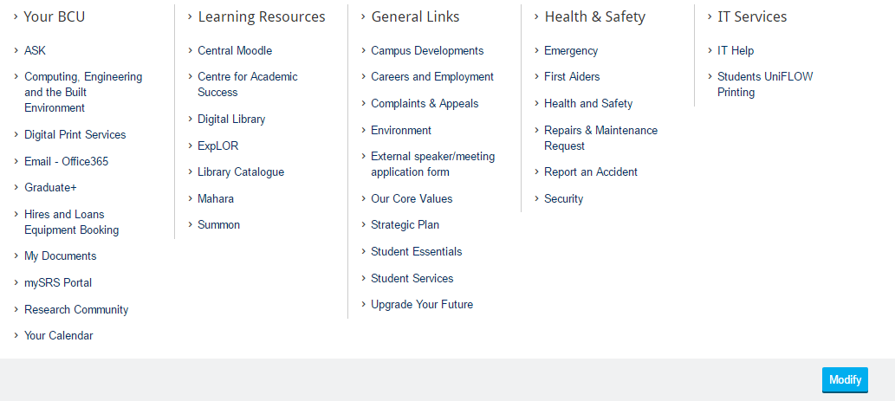
Source: (BIRMINGHAM CITY UNIVERSITY, 2015)
Figure 1 - Current BCU iCity Menu System
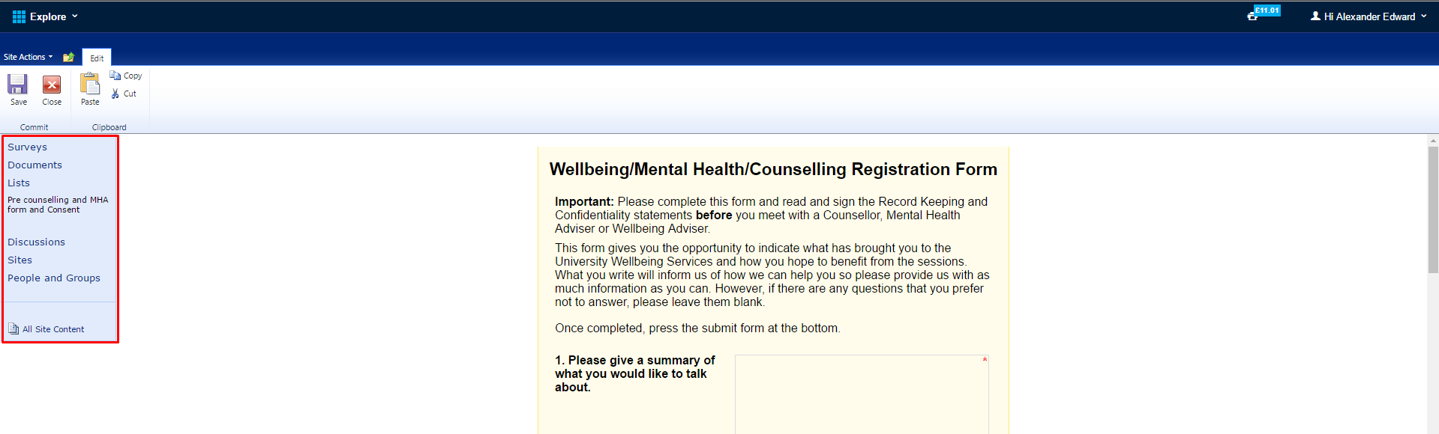
Source: (Birmingham City University, no date)
Figure 2 - Image showing sidebar not meant to be used by students
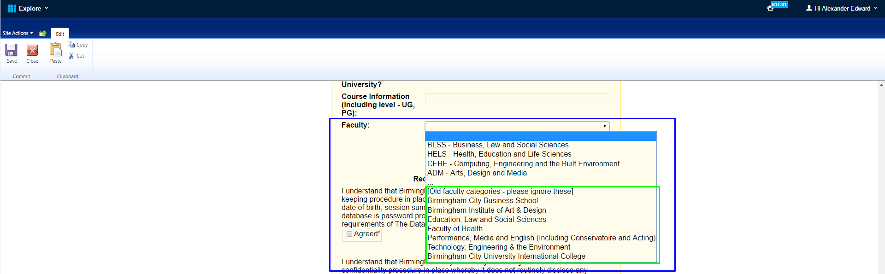
Source: (BIRMINGHAM CITY UNIVERSITY, NO DATE)
Figure 3 - Image showing question with unusable answers
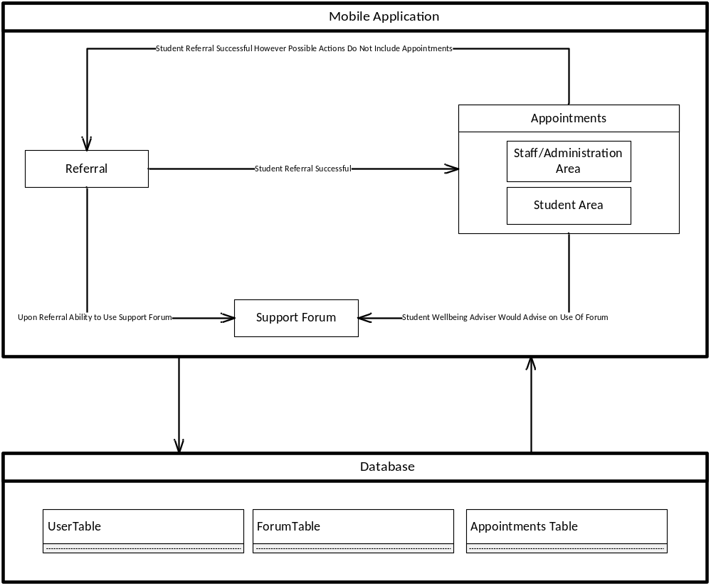
Figure 4 - Diagram of the three sections of the app and how a user could access the other sections of the app.

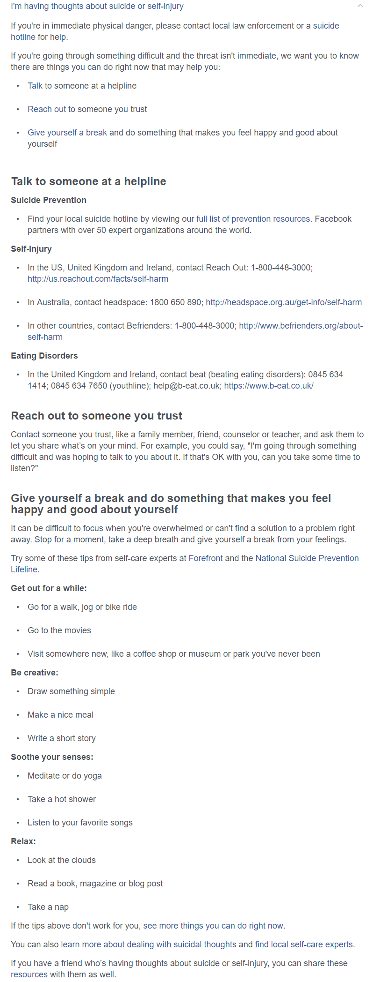
Source: (Facebook, 2017)
Figure 5 - Question giving advice regarding mental health issues
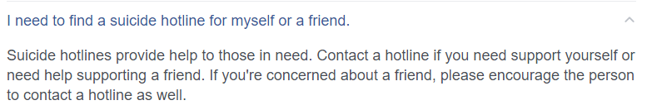
Source: (Facebook, 2017)
Figure 6 - Question giving advice regarding mental health issues
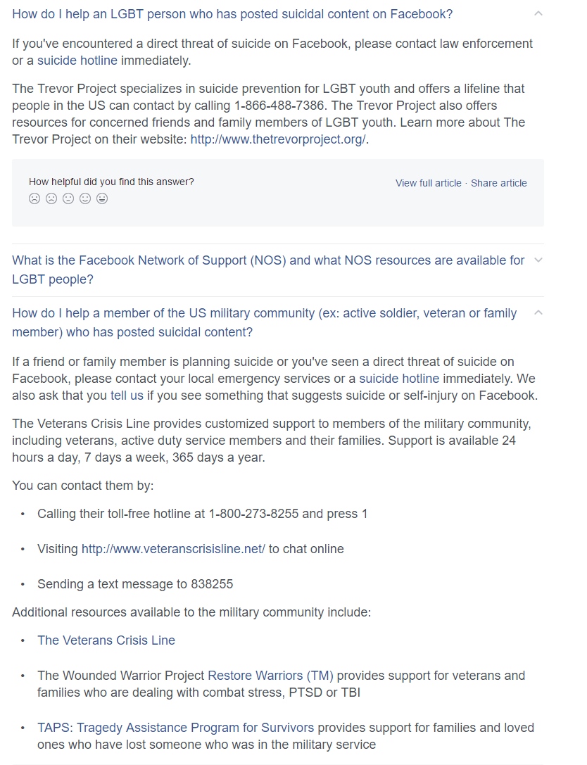
Source: (Facebook, 2017)
Figure 7 - Question giving advice regarding mental health issues

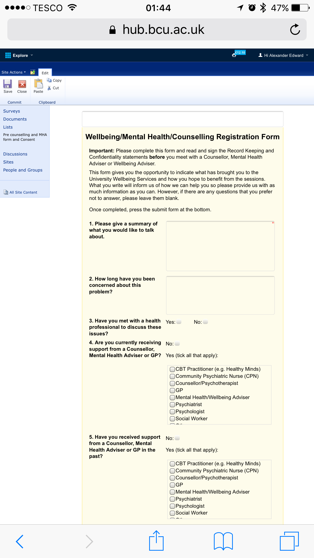
Source: (Birmingham City University, No Date)
Figure 8 - Screenshot of current system on a mobile device
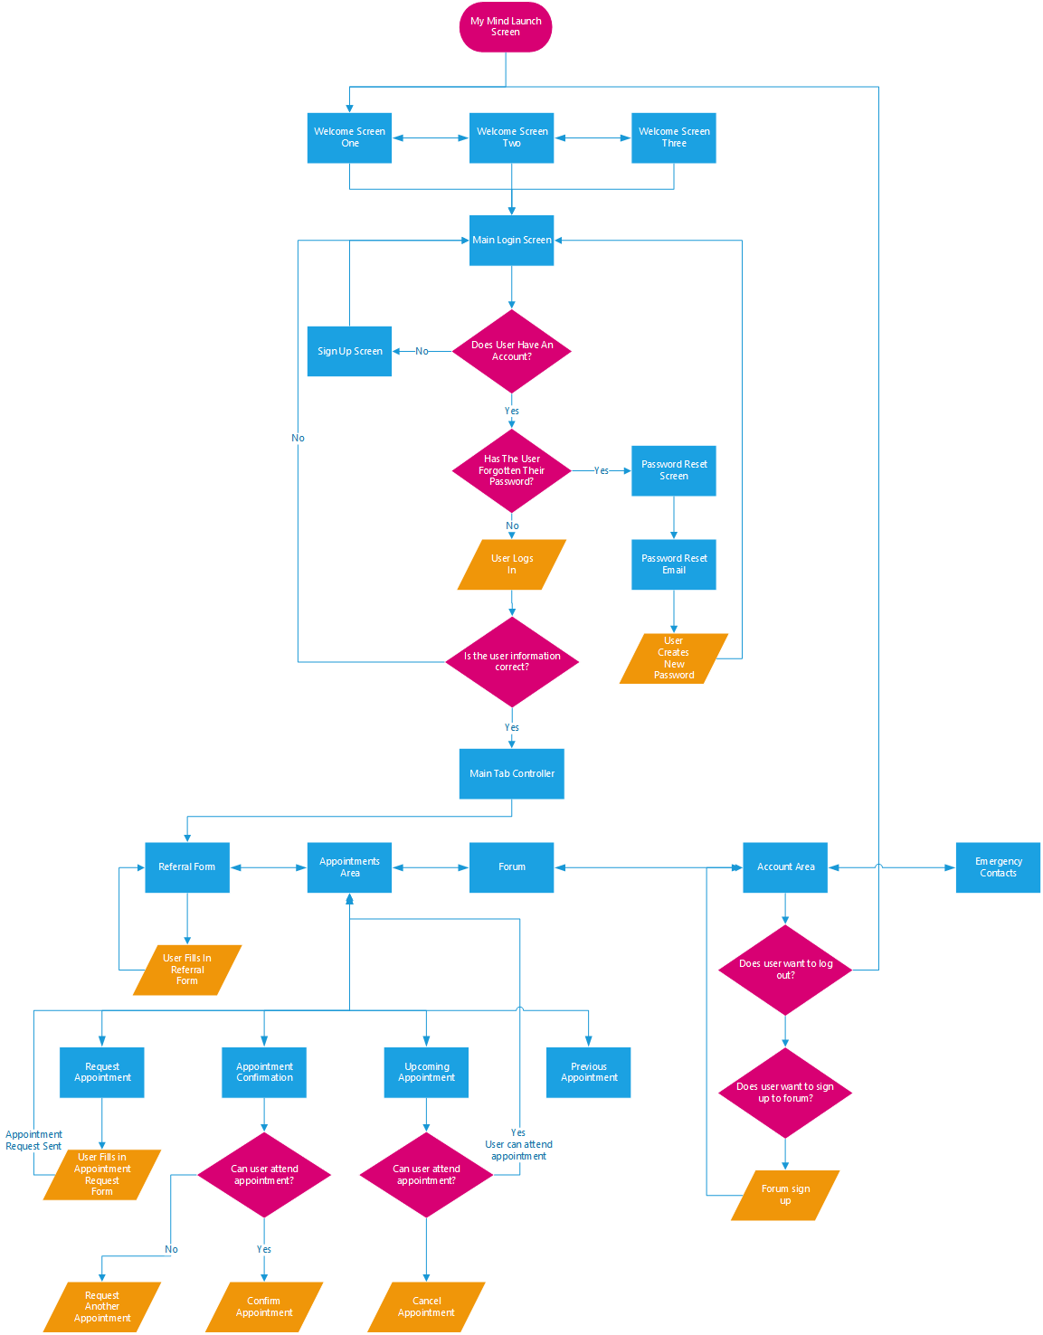
Figure 9 - Flowchart showing how the path a user would take within the My Mind app
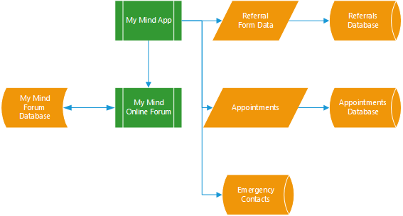
Figure 10 - Diagram showing structure of system
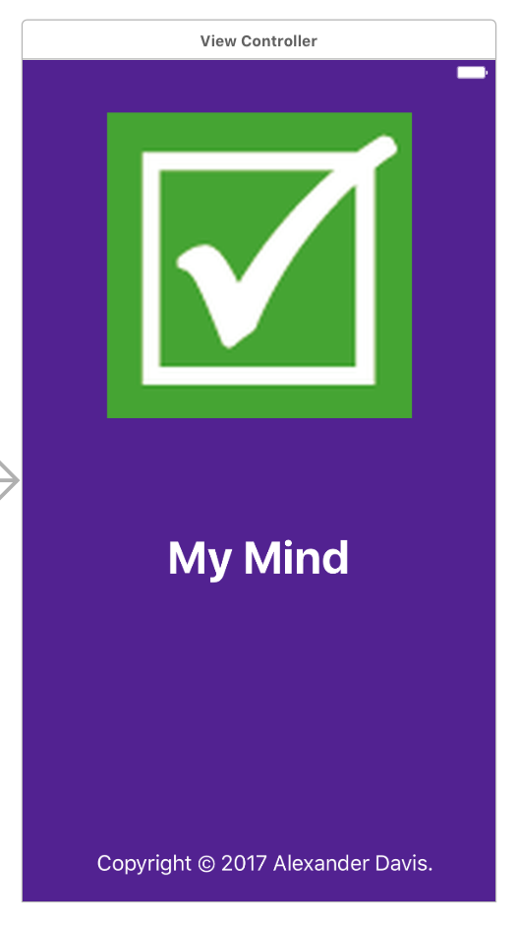
Figure 11 - Final Design of Launch Screen
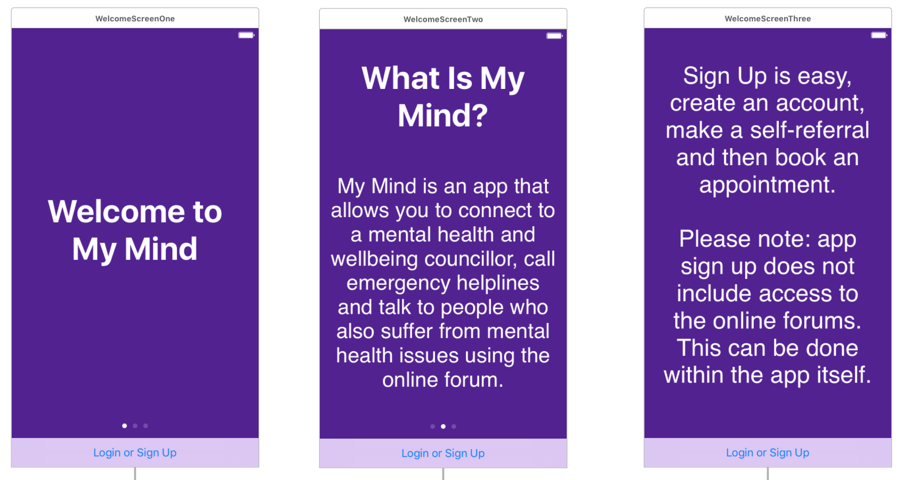
Figure 12 - Final Design of the Welcome Screens
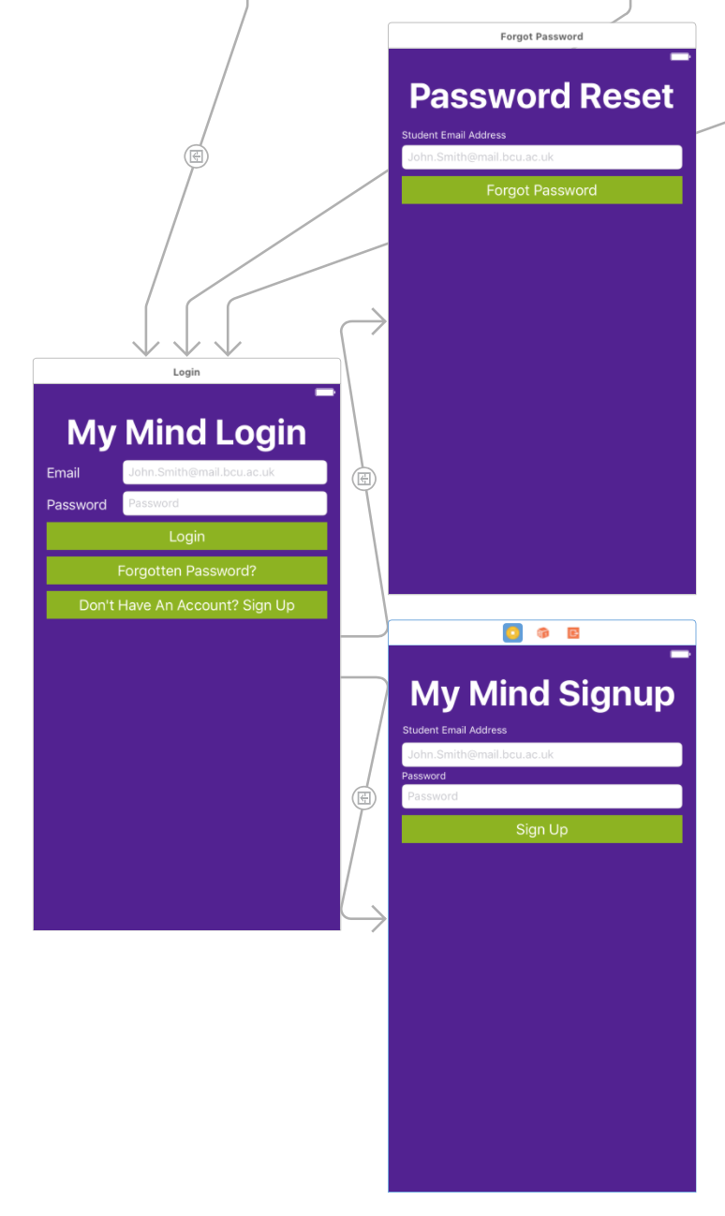
Figure 13 - Final Design for the Login Section
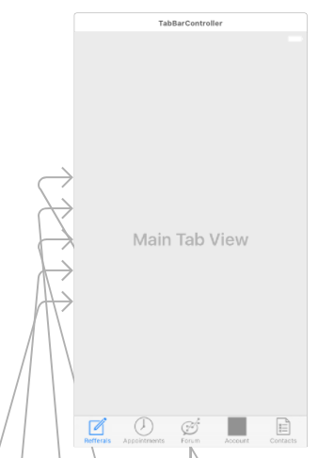
Figure 14 - Main Tab Controller
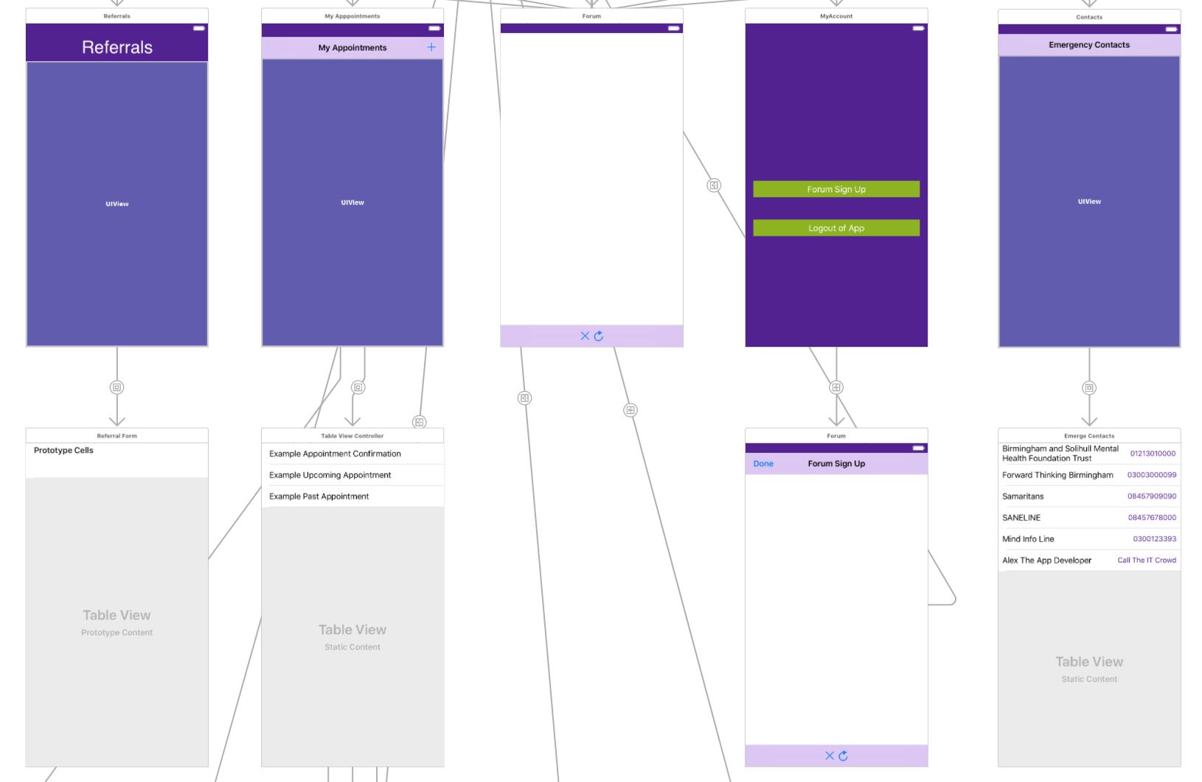
Figure 15 - Main App Designs (1)
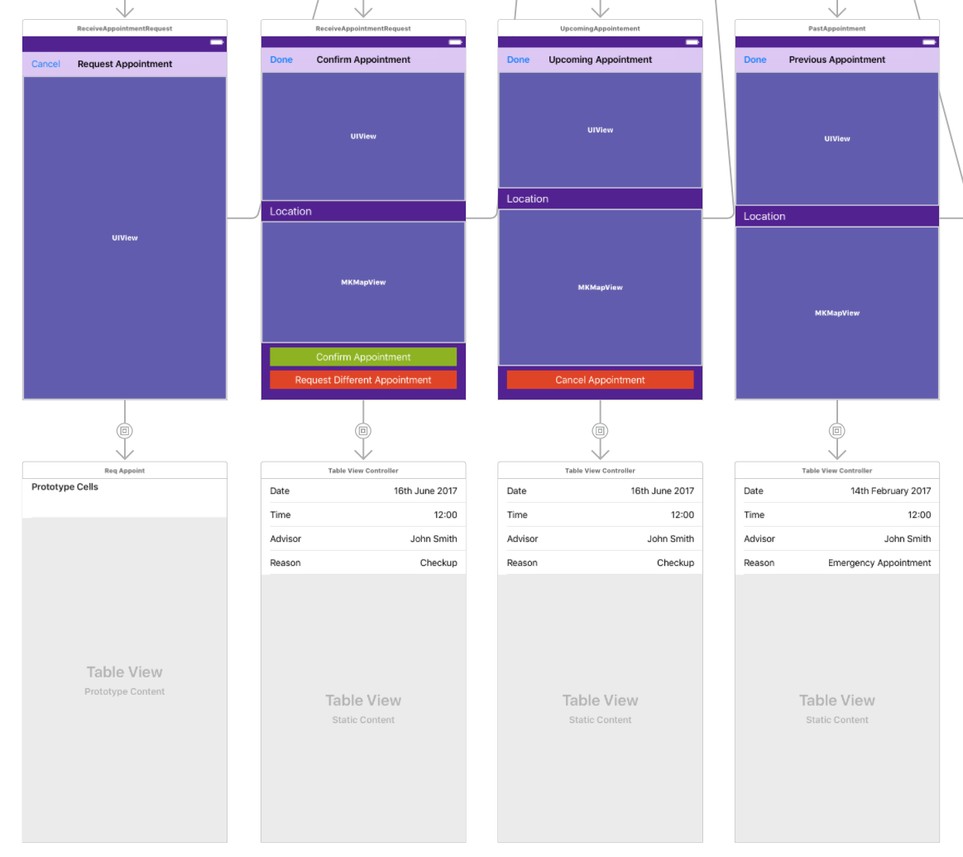
Figure 16 - Main App Designs (2)

Appendix B – Sample Questionnaire & Consent Form
Below is the content of the questionnaire to evaluate my app and the consent form for participation within the project.
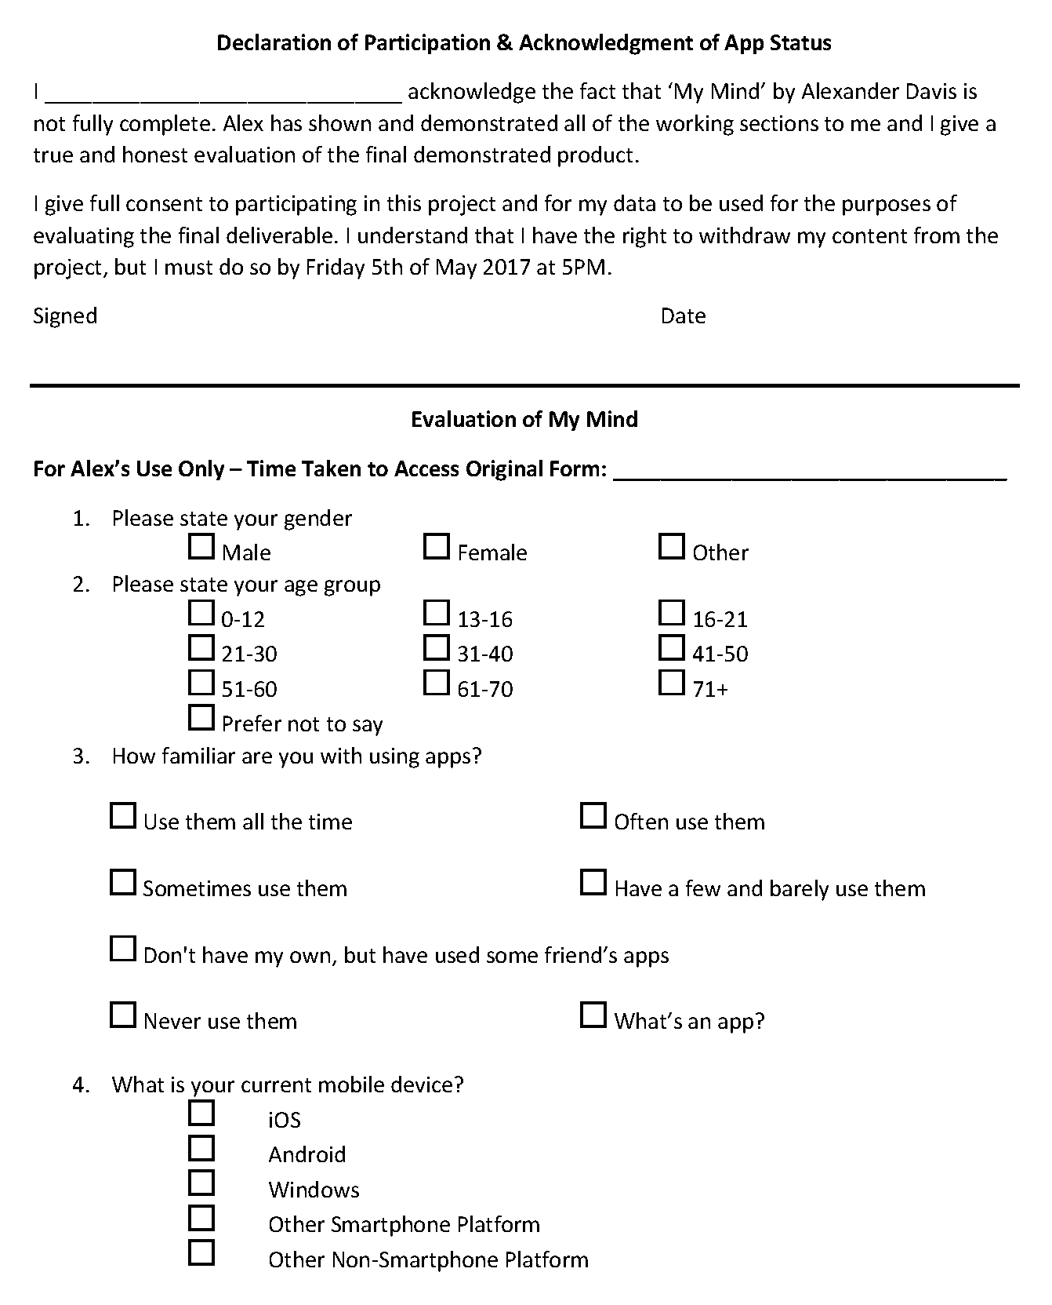
Figure 17 - Page 1 of product evaluation

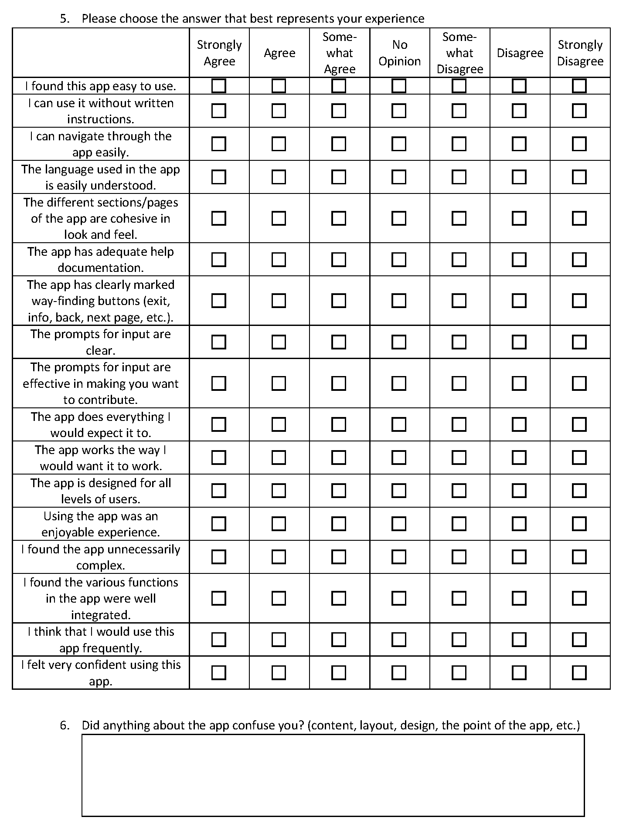
Figure 18 - Page 2 of product evaluation
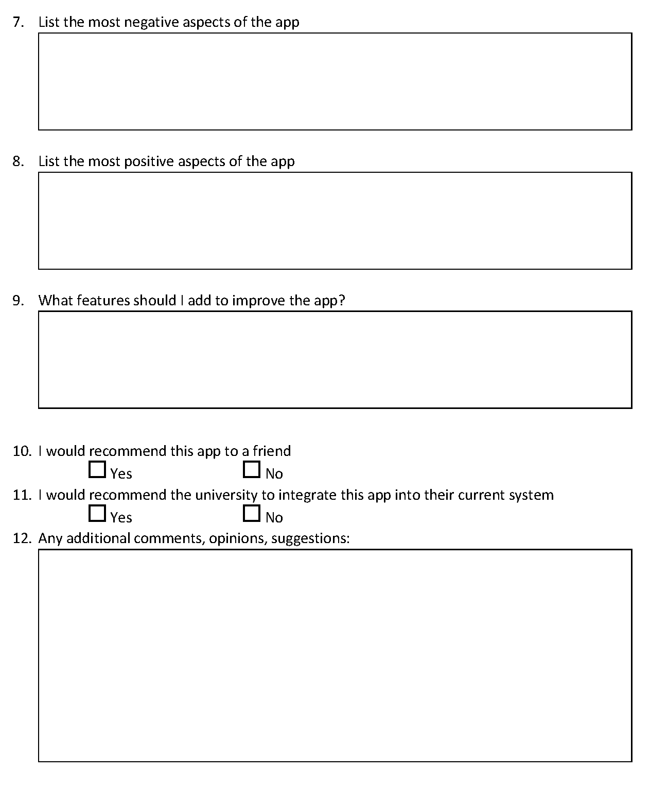
Figure 19 - Page 3 of product evaluation

Appendix C – Presentation
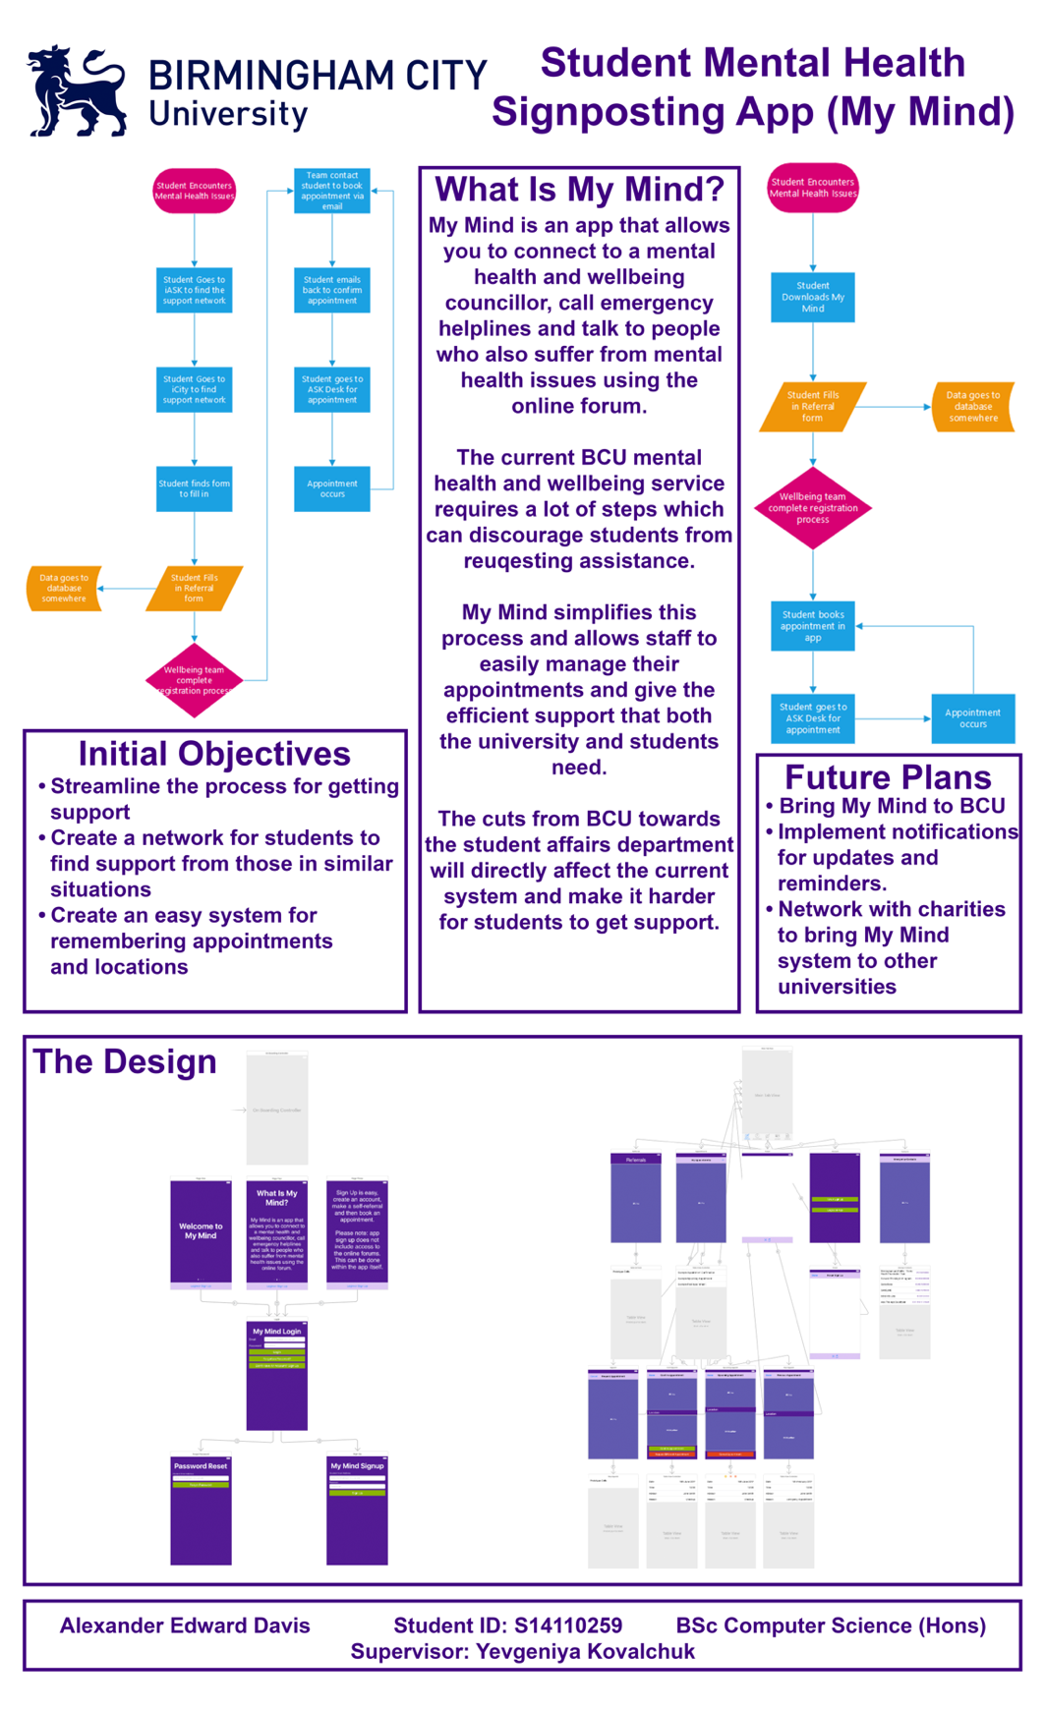
Figure 20 - Presentation Poster

Appendix D – Source Code

AppDelegate
//
// AppDelegate.swift
// My Mind
//
// Created by Alexander Davis on 09/04/2017.
// Copyright © 2017 Alexander Davis. All rights reserved.
//

import UIKit
import Firebase
import UserNotifications
import NotificationCenter
import FirebaseMessaging
import FirebaseDatabase

@UIApplicationMain
class AppDelegate: UIResponder, UIApplicationDelegate {

var window: UIWindow?
let gcmMessageIDKey = "gcm.message_id"

func application(_ application: UIApplication, didFinishLaunchingWithOptions launchOptions: [UIApplicationLaunchOptionsKey: Any]?) -> Bool {
// Use Firebase library to configure APIs
FIRApp.configure()
FIRDatabase.database().persistenceEnabled = true

//If User Is Signed In Direct to Main App Section
let currentUser = FIRAuth.auth()?.currentUser
let mainStoryboard = UIStoryboard(name: "Main", bundle: nil)
if currentUser != nil
{
self.window?.rootViewController = mainStoryboard.instantiateViewController(withIdentifier: "MainController")
}
else
{
self.window?.rootViewController = mainStoryboard.instantiateViewController(withIdentifier: "OnBoard")
}

//Turn On Notifications for App
if #available(iOS 10.0, *) {
// For iOS 10 display notification (sent via APNS)
UNUserNotificationCenter.current().delegate = self

let authOptions: UNAuthorizationOptions = [.alert, .badge, .sound]
UNUserNotificationCenter.current().requestAuthorization(
options: authOptions,
completionHandler: {_, _ in })

// For iOS 10 data message (sent via FCM)
FIRMessaging.messaging().remoteMessageDelegate = self as? FIRMessagingDelegate

} else {
let settings: UIUserNotificationSettings =
UIUserNotificationSettings(types: [.alert, .badge, .sound], categories: nil)
application.registerUserNotificationSettings(settings)
}

application.registerForRemoteNotifications()

return true
}

func applicationWillResignActive(_ application: UIApplication) {
// Sent when the application is about to move from active to inactive state. This can occur for certain types of temporary interruptions (such as an incoming phone call or SMS message) or when the user quits the application and it begins the transition to the background state.
// Use this method to pause ongoing tasks, disable timers, and invalidate graphics rendering callbacks. Games should use this method to pause the game.
}

func applicationDidEnterBackground(_ application: UIApplication) {
// Use this method to release shared resources, save user data, invalidate timers, and store enough application state information to restore your application to its current state in case it is terminated later.
// If your application supports background execution, this method is called instead of applicationWillTerminate: when the user quits.
}

func applicationWillEnterForeground(_ application: UIApplication) {
// Called as part of the transition from the background to the active state; here you can undo many of the changes made on entering the background.
}

func applicationDidBecomeActive(_ application: UIApplication) {
// Restart any tasks that were paused (or not yet started) while the application was inactive. If the application was previously in the background, optionally refresh the user interface.
}

func applicationWillTerminate(_ application: UIApplication) {
// Called when the application is about to terminate. Save data if appropriate. See also applicationDidEnterBackground:.
}

func application(_ application: UIApplication, didReceiveRemoteNotification userInfo: [AnyHashable: Any]) {
// If you are receiving a notification message while your app is in the background,
// this callback will not be fired till the user taps on the notification launching the application.
// TODO: Handle data of notification

// Print message ID.
if let messageID = userInfo[gcmMessageIDKey] {
print("Message ID: \(messageID)")
}

// Print full message.
print(userInfo)
}

func application(_ application: UIApplication, didReceiveRemoteNotification userInfo: [AnyHashable: Any],
fetchCompletionHandler completionHandler: @escaping (UIBackgroundFetchResult) -> Void) {
// If you are receiving a notification message while your app is in the background,
// this callback will not be fired till the user taps on the notification launching the application.
// TODO: Handle data of notification

// Print message ID.
if let messageID = userInfo[gcmMessageIDKey] {
print("Message ID: \(messageID)")
}

// Print full message.
print(userInfo)

completionHandler(UIBackgroundFetchResult.newData)
}
}

// [START ios_10_message_handling]
@available(iOS 10, *)
extension AppDelegate : UNUserNotificationCenterDelegate {

// Receive displayed notifications for iOS 10 devices.
func userNotificationCenter(_ center: UNUserNotificationCenter,
willPresent notification: UNNotification,
withCompletionHandler completionHandler: @escaping (UNNotificationPresentationOptions) -> Void) {
let userInfo = notification.request.content.userInfo
// Print message ID.
if let messageID = userInfo[gcmMessageIDKey] {
print("Message ID: \(messageID)")
}

// Print full message.
print(userInfo)

// Change this to your preferred presentation option
completionHandler([])
}

func userNotificationCenter(_ center: UNUserNotificationCenter,
didReceive response: UNNotificationResponse,
withCompletionHandler completionHandler: @escaping () -> Void) {
let userInfo = response.notification.request.content.userInfo
// Print message ID.
if let messageID = userInfo[gcmMessageIDKey] {
print("Message ID: \(messageID)")
}

// Print full message.
print(userInfo)

completionHandler()
}
}
// [END ios_10_message_handling]
// [START ios_10_data_message_handling]
extension AppDelegate : FIRMessagingDelegate {
// Receive data message on iOS 10 devices while app is in the foreground.
func applicationReceivedRemoteMessage(_ remoteMessage: FIRMessagingRemoteMessage) {
print(remoteMessage.appData)
}
}
// [END ios_10_data_message_handling]

OnBoardingController
//
// OnBoardingController.swift
// My Mind
//
// Created by Alexander Davis on 30/03/2017.
// Copyright © 2017 Alexander Davis. All rights reserved.
//

import Foundation
import UIKit

class OnBoardingController : UIPageViewController {

override var preferredStatusBarStyle: UIStatusBarStyle {
return .lightContent
}

override func viewDidLoad() {
// Set the dataSource and delegate in code.
// I can't figure out how to do this in the Storyboard!
dataSource = self
delegate = self
// This is the starting point. Start with step zero.
setViewControllers([getPageOne()], direction: .forward, animated: false, completion: nil)
}

func getPageOne() -> PageOne {
return storyboard!.instantiateViewController(withIdentifier: "WelcomeScreenOne") as! PageOne
}

func getPageTwo() -> PageTwo {
return storyboard!.instantiateViewController(withIdentifier: "WelcomeScreenTwo") as! PageTwo
}

func getPageThree() -> PageThree {
return storyboard!.instantiateViewController(withIdentifier: "WelcomeScreenThree") as! PageThree
}

}

// MARK: - UIPageViewControllerDataSource methods

extension OnBoardingController : UIPageViewControllerDataSource {

func pageViewController(_ pageViewController: UIPageViewController, viewControllerBefore viewController: UIViewController) -> UIViewController? {
if viewController.isKind(of: PageTwo.self) {
// 2 -> 1
return getPageTwo()
} else if viewController.isKind(of: PageTwo.self) {
// 1 -> 0
return getPageOne()
} else {
// 0 -> end of the road
return nil
}
}

func pageViewController(_ pageViewController: UIPageViewController, viewControllerAfter viewController: UIViewController) -> UIViewController? {
if viewController.isKind(of: PageOne.self) {
// 0 -> 1
return getPageTwo()
} else if viewController.isKind(of: PageTwo.self) {
// 1 -> 2
return getPageThree()
} else {
// 2 -> end of the road
return nil
}
}

// This only gets called once, when setViewControllers is called
func presentationIndex(for pageViewController: UIPageViewController) -> Int {
return 0
}

}

// MARK: - UIPageViewControllerDelegate methods

extension OnBoardingController : UIPageViewControllerDelegate {

}

Welcome Screens

WelcomeScreenOne
//
// WelcomeScreenOne.swift
// My Mind
//
// Created by Alexander Davis on 30/03/2017.
// Copyright © 2017 Alexander Davis. All rights reserved.
//

import Foundation
import UIKit

class PageOne : UIViewController {

override var preferredStatusBarStyle: UIStatusBarStyle {
return .lightContent
}

WelcomeScreenTwo
//
// WelcomeScreenTwo.swift
// My Mind
//
// Created by Alexander Davis on 30/03/2017.
// Copyright © 2017 Alexander Davis. All rights reserved.
//

import Foundation
import UIKit

class PageTwo : UIViewController {

override var preferredStatusBarStyle: UIStatusBarStyle {
return .lightContent
}

}

WelcomeScreenThree
//
// WelcomeScreenThree.swift
// My Mind
//
// Created by Alexander Davis on 30/03/2017.
// Copyright © 2017 Alexander Davis. All rights reserved.
//

import Foundation
import UIKit

class PageThree : UIViewController {

override var preferredStatusBarStyle: UIStatusBarStyle {
return .lightContent
}

}

Login Section and User Information

UserViews
//
// LoginView.swift
// My Mind
//
// Created by Alexander Davis on 31/03/2017.
// Copyright © 2017 Alexander Davis. All rights reserved.
//

import Foundation
import UIKit
import Firebase
import FirebaseAuth

class LoginView: UIViewController {

@IBOutlet weak var Emailtbx: UITextField!
@IBOutlet weak var Passwordtbx: UITextField!
@IBAction func Loginbtn(_ sender: UIButton) {
if self.Emailtbx.text == "" || self.Passwordtbx.text == "" {

//Alert to tell the user that there was an error because they didn't fill anything in the textfields because they didn't fill anything in

let alertController = UIAlertController(title: "Error", message: "Please enter an email and password.", preferredStyle: .alert)

let defaultAction = UIAlertAction(title: "OK", style: .cancel, handler: nil)
alertController.addAction(defaultAction)

self.present(alertController, animated: true, completion: nil)

} else {

FIRAuth.auth()?.signIn(withEmail: self.Emailtbx.text!, password: self.Passwordtbx.text!) { (user, error) in

if error == nil {

//Print into the console if successfully logged in
print("You have successfully logged in")

//Go to the MainController if the login is sucessful
let alertController = UIAlertController(title: "Welcome", message: "You have successfully logged in", preferredStyle: .alert)
let vc = self.storyboard?.instantiateViewController(withIdentifier: "MainController")
let defaultAction = UIAlertAction(title: "OK", style: .default, handler: { action in self.present(vc!, animated: true, completion: nil);})
alertController.addAction(defaultAction)

self.present(alertController, animated: true, completion: nil)

} else {

//Tells the user that there is an error and then gets firebase to tell them the error
let alertController = UIAlertController(title: "Error", message: error?.localizedDescription, preferredStyle: .alert)

let defaultAction = UIAlertAction(title: "OK", style: .cancel, handler: nil)
alertController.addAction(defaultAction)

self.present(alertController, animated: true, completion: nil)
}
}
}
}

override var preferredStatusBarStyle: UIStatusBarStyle {
return .lightContent
}
}

class SignUp : UIViewController {

@IBOutlet weak var Emailtbx: UITextField!
@IBOutlet weak var Passwordtbx: UITextField!
@IBAction func createAccountbtn(_ sender: UIButton) {
if Emailtbx.text == "" {
let alertController = UIAlertController(title: "Error", message: "Please enter your email and password", preferredStyle: .alert)

let defaultAction = UIAlertAction(title: "OK", style: .cancel, handler: nil)
alertController.addAction(defaultAction)

present(alertController, animated: true, completion: nil)

} else {
FIRAuth.auth()?.createUser(withEmail: Emailtbx.text!, password: Passwordtbx.text!) { (user, error) in

if error == nil {
let alertController = UIAlertController(title: "Sign Up Complete", message: "You have Successfully Signed Up", preferredStyle: .alert)
let vc = self.storyboard?.instantiateViewController(withIdentifier: "Login")
let defaultAction = UIAlertAction(title: "OK", style: .default, handler: { action in self.present(vc!, animated: true, completion: nil);})
alertController.addAction(defaultAction)

self.present(alertController, animated: true, completion: nil)

} else {
let alertController = UIAlertController(title: "Error", message: error?.localizedDescription, preferredStyle: .alert)

let defaultAction = UIAlertAction(title: "OK", style: .cancel, handler: nil)
alertController.addAction(defaultAction)

self.present(alertController, animated: true, completion: nil)
}
}
}
}

override var preferredStatusBarStyle: UIStatusBarStyle {
return .lightContent
}
}

class ForgotPass : UIViewController {

@IBOutlet weak var Emailtbx: UITextField!
@IBAction func Resetbtn(_ sender: UIButton) {
if self.Emailtbx.text == "" {
let alertController = UIAlertController(title: "Oops!", message: "Please enter an email.", preferredStyle: .alert)

let defaultAction = UIAlertAction(title: "OK", style: .cancel, handler: nil)
alertController.addAction(defaultAction)

present(alertController, animated: true, completion: nil)

} else {
FIRAuth.auth()?.sendPasswordReset(withEmail: self.Emailtbx.text!, completion: { (error) in

var title = ""
var message = ""

if error != nil {
title = "Error!"
message = (error?.localizedDescription)!
} else {
title = "Success!"
message = "Password reset email sent."
self.Emailtbx.text = ""
}

let alertController = UIAlertController(title: title, message: message, preferredStyle: .alert)

let vc = self.storyboard?.instantiateViewController(withIdentifier: "Login")
let defaultAction = UIAlertAction(title: "OK", style: .cancel, handler: { action in self.present(vc!, animated: true, completion: nil);})
alertController.addAction(defaultAction)

self.present(alertController, animated: true, completion: nil)
})
}
}

override var preferredStatusBarStyle: UIStatusBarStyle {
return .lightContent
}
}

class Logout : UIViewController {

@IBAction func Logoutbtn(_ sender: UIButton) {
if FIRAuth.auth()?.currentUser != nil {
do {
try FIRAuth.auth()?.signOut()
let vc = UIStoryboard(name: "Main", bundle: nil).instantiateViewController(withIdentifier: "OnBoard")
present(vc, animated: true, completion: nil)

} catch let error as NSError {
print(error.localizedDescription)
}
}
}

override var preferredStatusBarStyle: UIStatusBarStyle {
return .lightContent
}
}

Main Tab Views

TabBarController
//
// TabBarController.swift
// My Mind
//
// Created by Alexander Davis on 05/04/2017.
// Copyright © 2017 Alexander Davis. All rights reserved.
//

import Foundation
import UIKit

class MainTabView: UITabBarController{
override var preferredStatusBarStyle: UIStatusBarStyle {
return .lightContent
}
}

MainViews
//
// MainViews.swift
// My Mind
//
// Created by Alexander Davis on 09/04/2017.
// Copyright © 2017 Alexander Davis. All rights reserved.
//

import Foundation
import UIKit
import Firebase
import FirebaseDatabase

class Referrals: UIViewController{
override var preferredStatusBarStyle: UIStatusBarStyle {
return .lightContent
}
}

class ReferralConf: UIViewController{
override var preferredStatusBarStyle: UIStatusBarStyle {
return .lightContent
}
}

class Appoint: UIViewController{
override var preferredStatusBarStyle: UIStatusBarStyle {
return .lightContent
}
}

class Contact: UIViewController{
override var preferredStatusBarStyle: UIStatusBarStyle {
return .lightContent
}
}

class EmergeContacts: UITableViewController{
@IBAction func TrustCallBtn(_ sender: UIButton) {
if let url = URL(string: "telprompt://01213010000")
{
UIApplication.shared.open(url, options: [:], completionHandler: nil)
}
}

@IBAction func FwdThinkingbtn(_ sender: UIButton) {
if let url = URL(string: "telprompt://03003000099")
{
UIApplication.shared.open(url, options: [:], completionHandler: nil)
}
}

@IBAction func Samaritansbtn(_ sender: UIButton) {
if let url = URL(string: "telprompt://08457909090")
{
UIApplication.shared.open(url, options: [:], completionHandler: nil)
}
}

@IBAction func Sanebtn(_ sender: UIButton) {
if let url = URL(string: "telprompt://08457678000")
{
UIApplication.shared.open(url, options: [:], completionHandler: nil)
}
}

@IBAction func Mindbtn(_ sender: UIButton) {
if let url = URL(string: "telprompt://0300123393")
{
UIApplication.shared.open(url, options: [:], completionHandler: nil)
}
}

@IBAction func Alexsbtn(_ sender: UIButton) {
if let url = URL(string: "telprompt://07871778000")
{
UIApplication.shared.open(url, options: [:], completionHandler: nil)
}
}
}

FormViews
//
// FormViews.swift
// My Mind
//
// Created by Alexander Davis on 11/04/2017.
// Copyright © 2017 Alexander Davis. All rights reserved.
//

import Foundation
import UIKit
import SwiftForms
import MessageUI
import MapKit

class ReferralForm: FormViewController, MFMailComposeViewControllerDelegate{
override var preferredStatusBarStyle: UIStatusBarStyle {
return .lightContent
}

struct Static {
static let nameTag = "name"
static let passwordTag = "password"
static let lastNameTag = "lastName"
static let addressTag = "address"
static let IDTag = "idnumber"
static let GenderTag = "gender"
static let personalEmailTag = "personalemail"
static let uniEmailTag = "universityemail"
static let CourseTag = "course"
static let phoneTag = "phone"
static let Voicemail = "voicemail"
static let DSATag = "disabledstudent"
static let FacultyTag = "faculty"
static let birthday = "birthday"
static let PastSupportTag = "pastsupport"
static let CurrentSupportTag = "currentsupport"
static let subjectTag = "subject"
static let timescaleTag = "timescale"
static let button = "button"
}

required init(coder aDecoder: NSCoder) {
super.init(coder: aDecoder)
self.loadForm()
}

override func viewDidLoad() {
super.viewDidLoad()
//self.navigationItem.rightBarButtonItem = UIBarButtonItem(title: "Submit", style: .plain, target: self, action: #selector(ReferralForm.submit(_:)))
}

// MARK: Actions

func submit() {

let data = self.form.formValues().description

let alertController = UIAlertController(title: "Form Completed", message: "This form has sucessfully been submitted", preferredStyle: .alert)

let vc = self.storyboard?.instantiateViewController(withIdentifier: "MainController")
let defaultAction = UIAlertAction(title: "OK", style: .default, handler: { action in SendRef(input: data);self.tabBarController!.tabBar.items?[0].isEnabled = false;self.present(vc!, animated: true, completion: nil);})
alertController.addAction(defaultAction)
self.present(alertController, animated: true, completion: nil)
}

// MARK: Private interface

fileprivate func loadForm() {

let form = FormDescriptor(title: "Referral Form")

let section1 = FormSectionDescriptor(headerTitle: nil, footerTitle: nil)

var row = FormRowDescriptor(tag: Static.button, type: .button, title: "Send Form")
row.configuration.button.didSelectClosure = { _ in
self.view.endEditing(true)
self.submit()
}
section1.rows.append(row)

let section2 = FormSectionDescriptor(headerTitle: "About Yourself", footerTitle: nil)

row = FormRowDescriptor(tag: Static.nameTag, type: .name, title: "First Name")
row.configuration.cell.appearance = ["textField.placeholder" : "First Name" as AnyObject, "textField.textAlignment" : NSTextAlignment.right.rawValue as AnyObject]
section2.rows.append(row)

row = FormRowDescriptor(tag: Static.lastNameTag, type: .name, title: "Last Name")
row.configuration.cell.appearance = ["textField.placeholder" : "Last name" as AnyObject, "textField.textAlignment" : NSTextAlignment.right.rawValue as AnyObject]
section2.rows.append(row)

row = FormRowDescriptor(tag: Static.IDTag, type: .number, title: "Student ID")
row.configuration.cell.appearance = ["textField.placeholder" : "12345678" as AnyObject, "textField.textAlignment" : NSTextAlignment.right.rawValue as AnyObject]
section2.rows.append(row)

row = FormRowDescriptor(tag: Static.birthday, type: .date, title: "Date of Birth")
row.configuration.cell.showsInputToolbar = true
section2.rows.append(row)

row = FormRowDescriptor(tag: Static.uniEmailTag, type: .email, title: "University Email")
row.configuration.cell.appearance = ["textField.placeholder" : "john.smith@mail.bcu.ac.uk" as AnyObject, "textField.textAlignment" : NSTextAlignment.right.rawValue as AnyObject]
section2.rows.append(row)

row = FormRowDescriptor(tag: Static.personalEmailTag, type: .email, title: "Alternative Email")
row.configuration.cell.appearance = ["textField.placeholder" : "john.smith@outlook.com" as AnyObject, "textField.textAlignment" : NSTextAlignment.right.rawValue as AnyObject]
section2.rows.append(row)

row = FormRowDescriptor(tag: Static.phoneTag, type: .phone, title: "Phone")
row.configuration.cell.appearance = ["textField.placeholder" : "Mobile Number" as AnyObject, "textField.textAlignment" : NSTextAlignment.right.rawValue as AnyObject]
section2.rows.append(row)

row = FormRowDescriptor(tag: Static.Voicemail, type: .booleanSwitch, title: "Can we leave a voicemail message?")
section2.rows.append(row)

row = FormRowDescriptor(tag: Static.GenderTag, type: .picker, title: "Gender")
row.configuration.cell.showsInputToolbar = true
row.configuration.selection.options = (["F", "M", "O", "U"] as [String]) as [AnyObject]
row.configuration.selection.optionTitleClosure = { value in
guard let option = value as? String else { return "" }
switch option {
case "F":
return "Female"
case "M":
return "Male"
case "O":
return "Other"
case "U":
return "I'd rather not to say"
default:
return ""
}
}
section2.rows.append(row)

row = FormRowDescriptor(tag: Static.addressTag, type: .multilineText, title: "Address")
section2.rows.append(row)

row = FormRowDescriptor(tag: Static.DSATag, type: .booleanSwitch, title: "Are you a disabled student (eligible for DSA)?")
section2.rows.append(row)

row = FormRowDescriptor(tag: Static.CourseTag, type: .text, title: "Course")
row.configuration.cell.appearance = ["textField.placeholder" : "BSc Computer Science (Hons)" as AnyObject, "textField.textAlignment" : NSTextAlignment.right.rawValue as AnyObject]
section2.rows.append(row)

row = FormRowDescriptor(tag: Static.FacultyTag, type: .picker, title: "Faculty")
row.configuration.cell.showsInputToolbar = true
row.configuration.selection.options = (["CEBE", "HELS", "ADM", "BLSS"] as [String]) as [AnyObject]
row.configuration.selection.optionTitleClosure = { value in
guard let option = value as? String else { return "" }
switch option {
case "CEBE":
return "Computing, Engineering and The Built Environment"
case "HELS":
return "Health, Education and Life Sciences"
case "ADM":
return "Arts, Design and Media"
case "BLSS":
return "Business, Law and Social Sciences"
default:
return ""
}
}

section2.rows.append(row)

let section3 = FormSectionDescriptor(headerTitle: "What you would like to talk about.", footerTitle: nil)
row = FormRowDescriptor(tag: Static.subjectTag, type: .multilineText, title: "")
section3.rows.append(row)

row = FormRowDescriptor(tag: Static.timescaleTag, type: .picker, title: "How long have you been concerned?")
row.configuration.cell.showsInputToolbar = true
row.configuration.selection.options = (["NL", "ST", "QL", "VL"] as [String]) as [AnyObject]
row.configuration.selection.optionTitleClosure = { value in
guard let option = value as? String else { return "" }
switch option {
case "NL":
return "Not Long (within 1 month)"
case "ST":
return "Some Time (1-3 months)"
case "QL":
return "Quite Some Time (3-6 months)"
case "VL":
return "A Long Time (6+ months)"
default:
return ""
}
}
section3.rows.append(row)

row = FormRowDescriptor(tag: Static.CurrentSupportTag, type: .multipleSelector, title: "Are you currently receiving support?")
row.configuration.cell.showsInputToolbar = true
row.configuration.selection.options = (["No", "CBT", "CPN", "CP", "GP", "MHWA", "Psyi", "Psyo", "SW", "O"] as [String]) as [AnyObject]
row.configuration.selection.optionTitleClosure = { value in
guard let option = value as? String else { return "" }
switch option {
case "No":
return "No"
case "CBT":
return "CBT Practitioner (e.g. Healthy Minds)"
case "CPN":
return "Community Psychiatric Nurse (CPN)"
case "CP":
return "Counsellor/Psychotherapist"
case "GP":
return "GP"
case "MHWA":
return "Mental Health/Wellbeing Adviser"
case "Psyi":
return "Psychiatrist"
case "Psyo":
return "Psychologist"
case "SW":
return "Social Worker"
case "O":
return "Other"
default:
return ""
}
}

section3.rows.append(row)

row = FormRowDescriptor(tag: Static.PastSupportTag, type: .multipleSelector, title: "Have you received support in the past?")
row.configuration.cell.showsInputToolbar = true
row.configuration.selection.options = (["No", "CBT", "CPN", "CP", "GP", "MHWA", "Psyi", "Psyo", "SW", "O"] as [String]) as [AnyObject]
row.configuration.selection.optionTitleClosure = { value in
guard let option = value as? String else { return "" }
switch option {
case "No":
return "No"
case "CBT":
return "CBT Practitioner (e.g. Healthy Minds)"
case "CPN":
return "Community Psychiatric Nurse (CPN)"
case "CP":
return "Counsellor/Psychotherapist"
case "GP":
return "GP"
case "MHWA":
return "Mental Health/Wellbeing Adviser"
case "Psyi":
return "Psychiatrist"
case "Psyo":
return "Psychologist"
case "SW":
return "Social Worker"
case "O":
return "Other"
default:
return ""
}
}

section3.rows.append(row)

form.sections = [section1, section2, section3]

self.form = form
}
}

class ReqAppoint: FormViewController, MFMailComposeViewControllerDelegate{
override var preferredStatusBarStyle: UIStatusBarStyle {
return .lightContent
}

struct Static {
static let date = "date"
static let time = "time"
static let location = "location"
static let phoneTag = "phone"
static let adivsor = "advisor"
static let reason = "reason"
static let button = "button"
}

required init(coder aDecoder: NSCoder) {
super.init(coder: aDecoder)
self.loadForm()
}

override func viewDidLoad() {
super.viewDidLoad()
//self.navigationItem.rightBarButtonItem = UIBarButtonItem(title: "Submit", style: .plain, target: self, action: #selector(ReferralForm.submit(_:)))
}

// MARK: Actions

func submit() {

let data = self.form.formValues().description

let alertController = UIAlertController(title: "Request Sent", message: "Your Request Has Been Sent", preferredStyle: .alert)

let vc = self.storyboard?.instantiateViewController(withIdentifier: "MainController")
let defaultAction = UIAlertAction(title: "OK", style: .default, handler: { action in SendRef(input: data);self.tabBarController!.tabBar.items?[0].isEnabled = false;self.present(vc!, animated: true, completion: nil);})
alertController.addAction(defaultAction)
self.present(alertController, animated: true, completion: nil)
}

// MARK: Private interface

fileprivate func loadForm() {

let form = FormDescriptor(title: "Referral Form")

let section1 = FormSectionDescriptor(headerTitle: nil, footerTitle: nil)

var row = FormRowDescriptor(tag: Static.button, type: .button, title: "Send Form")
row.configuration.button.didSelectClosure = { _ in
self.view.endEditing(true)
self.submit()
}
section1.rows.append(row)

let section2 = FormSectionDescriptor(headerTitle: nil, footerTitle: nil)

row = FormRowDescriptor(tag: Static.date, type: .date, title: "Date Requested")
row.configuration.cell.showsInputToolbar = true
section2.rows.append(row)

row = FormRowDescriptor(tag: Static.time, type: .time, title: "Time Requested")
row.configuration.cell.showsInputToolbar = true
section2.rows.append(row)

row = FormRowDescriptor(tag: Static.location, type: .picker, title: "Location")
row.configuration.cell.showsInputToolbar = true
row.configuration.selection.options = (["Centre", "North", "South", "Cons", "Margaret", "Jew","Bour"] as [String]) as [AnyObject]
row.configuration.selection.optionTitleClosure = { value in
guard let option = value as? String else { return "" }
switch option {
case "Centre":
return "City Centre (Curzon Building)"
case "North":
return "City North (Baker Building)"
case "South":
return "City South (Seacole Building)"
case "Cons":
return "The Birmingham Conservatoire"
case "Margaret":
return "Margaret Street"
case "Jew":
return "Victoria Street"
case "Bour":
return "Bournville Campus"
default:
return ""
}
}

section2.rows.append(row)

row = FormRowDescriptor(tag: Static.phoneTag, type: .phone, title: "Phone")
row.configuration.cell.appearance = ["textField.placeholder" : "Mobile Number" as AnyObject, "textField.textAlignment" : NSTextAlignment.right.rawValue as AnyObject]
section2.rows.append(row)

row = FormRowDescriptor(tag: Static.adivsor, type: .picker, title: "Preferred Advisor")
row.configuration.cell.showsInputToolbar = true
row.configuration.selection.options = (["JS", "AD", "TM", "U"] as [String]) as [AnyObject]
row.configuration.selection.optionTitleClosure = { value in
guard let option = value as? String else { return "" }
switch option {
case "JS":
return "John Smith"
case "AD":
return "Alexander Davis"
case "TM":
return "Tim Minchin"
case "U":
return "I Don't Mind"
default:
return ""
}
}
section2.rows.append(row)

row = FormRowDescriptor(tag: Static.reason, type: .multilineText, title: "Reason for Appointment")
section2.rows.append(row)

form.sections = [section1, section2]

self.form = form
}
}

class ConfAppoint: UIViewController{
@IBOutlet var ConfirmMap: MKMapView!
override func viewDidLoad() {
let initalLocation = CLLocation(latitude: 52.483358, longitude: -1.883024)
centerMapOnLocation(location: initalLocation)
}
override var preferredStatusBarStyle: UIStatusBarStyle {
return .lightContent
}

let regionRadius: CLLocationDistance = 1000
func centerMapOnLocation(location: CLLocation) {
let coordinateRegion = MKCoordinateRegionMakeWithDistance(location.coordinate,
regionRadius * 2.0, regionRadius * 2.0)
ConfirmMap.setRegion(coordinateRegion, animated: true)
}
@IBAction func Confirm(_ sender: UIButton) {
let alertController = UIAlertController(title: "Appointment Confirmed", message: "Your appointment has been confirmed.", preferredStyle: .alert)

let vc = self.storyboard?.instantiateViewController(withIdentifier: "MainController")
let defaultAction = UIAlertAction(title: "OK", style: .default, handler: { action in self.present(vc!, animated: true, completion: nil);})
alertController.addAction(defaultAction)

self.present(alertController, animated: true, completion: nil)
}
@IBAction func RequestAptbtn(_ sender: UIButton) {
let alertController = UIAlertController(title: "New Request Made", message: "A new appointment request has been made for you.", preferredStyle: .alert)

let vc = self.storyboard?.instantiateViewController(withIdentifier: "MainController")
let defaultAction = UIAlertAction(title: "OK", style: .default, handler: { action in self.present(vc!, animated: true, completion: nil);})
alertController.addAction(defaultAction)

self.present(alertController, animated: true, completion: nil)
}
}

class UpcomingAppoint: UIViewController{
@IBOutlet var UpcomingMap: MKMapView!
override func viewDidLoad() {
let initalLocation = CLLocation(latitude: 52.483358, longitude: -1.883024)
centerMapOnLocation(location: initalLocation)
}
override var preferredStatusBarStyle: UIStatusBarStyle {
return .lightContent
}

let regionRadius: CLLocationDistance = 1000
func centerMapOnLocation(location: CLLocation) {
let coordinateRegion = MKCoordinateRegionMakeWithDistance(location.coordinate,
regionRadius * 2.0, regionRadius * 2.0)
UpcomingMap.setRegion(coordinateRegion, animated: true)
}
@IBAction func Cancelbtn(_ sender: UIButton) {
let alertController = UIAlertController(title: "Appointment Cancelled", message: "Your appointment has been cancelled.", preferredStyle: .alert)

let vc = self.storyboard?.instantiateViewController(withIdentifier: "MainController")
let defaultAction = UIAlertAction(title: "OK", style: .default, handler: { action in self.present(vc!, animated: true, completion: nil);})
alertController.addAction(defaultAction)

self.present(alertController, animated: true, completion: nil)
}
}

class PastAppoint: UIViewController{
override func viewDidLoad() {
let initalLocation = CLLocation(latitude: 52.483358, longitude: -1.883024)
centerMapOnLocation(location: initalLocation)
}
override var preferredStatusBarStyle: UIStatusBarStyle {
return .lightContent
}

@IBOutlet var PastMap: MKMapView!

let regionRadius: CLLocationDistance = 1000
func centerMapOnLocation(location: CLLocation) {
let coordinateRegion = MKCoordinateRegionMakeWithDistance(location.coordinate,
regionRadius * 2.0, regionRadius * 2.0)
PastMap.setRegion(coordinateRegion, animated: true)
}

}

ForumView
//
// ForumView.swift
// My Mind
//
// Created by Alexander Davis on 31/03/2017.
// Copyright © 2017 Alexander Davis. All rights reserved.
//

import Foundation
import UIKit

class ForumViewController: UIViewController {

override var preferredStatusBarStyle: UIStatusBarStyle {
return .lightContent
}

@IBOutlet var webView: UIWebView!

override func viewDidLoad() {
super.viewDidLoad()
// Do any additional setup after loading the view, typically from a nib.
let url = URL (string: "https://www.mymindforum.com");
let requestObj = URLRequest(url: url!);
webView.loadRequest(requestObj);
}

override func didReceiveMemoryWarning() {
super.didReceiveMemoryWarning()
// Dispose of any resources that can be recreated.
}

}

class ForumSignUpViewController: UIViewController {

override var preferredStatusBarStyle: UIStatusBarStyle {
return .lightContent
}

@IBOutlet weak var ForumSignUp: UIWebView!

override func viewDidLoad() {
super.viewDidLoad()
// Do any additional setup after loading the view, typically from a nib.
let url = URL (string: "https://www.mymindforum.com/ucp.php?mode=register");
let requestObj = URLRequest(url: url!);
ForumSignUp.loadRequest(requestObj);
}

override func didReceiveMemoryWarning() {
super.didReceiveMemoryWarning()
// Dispose of any resources that can be recreated.
}

}

Appendix E – Test Plans

Login System
Field Name(s) | Input | Required Output | Output
Email Address  Password | test1@alexfyp.com  Test1Passw0rd | Welcome  You have successfully logged in | Welcome  You have successfully logged in
Email Address  Password | test1@alexfyp.com  [empty] | Error  Please enter an email and password. | Error  Please enter an email and password.
Email Address  Password | test1@alexfyp.com  ajgrtbugohsneg | Error  The password is invalid or the user does not have a password. | Error  The password is invalid or the user does not have a password.
Email Address  Password | ThisIsNotAnEmailAddress  Test1Passw0rd | Error  The email address is badly formatted | Error  The email address is badly formatted
Email Address  Password | fakeemail@alexsfyp.com  Test1Passw0rd | Error  There is no user record corresponding to this identifier. The user may have been deleted. | Error  There is no user record corresponding to this identifier. The user may have been deleted.
Email Address  Password | [empty]  Test1Passw0rd | Error  Please enter an email and password | Error  Please enter an email and password.
Email Address  Password | [empty]  [empty] | Error  Please enter an email and password. | Error  Please enter an email and password.
Table 2 - Test Plan for Login Screen
Field Name(s) | Input | Required Output | Output
Email Address  Password | test1@alexfyp.com  Test1Passw0rd | Sign Up Complete  You have Successfully Signed Up | Sign Up Complete  You have Successfully Signed Up
Email Address  Password | test1@alexfyp.com  [empty] | Error  Please enter your email and password. | Error  Please enter your email and password.
Email Address  Password | ThisIsNotAnEmailAddress  Test1Passw0rd | Error  The email address is badly formatted | Error  The email address is badly formatted
Email Address  Password | [empty]  Test1Passw0rd | Error  Please enter your email and password. | Error  Please enter your email and password.
Email Address  Password | [empty]  [empty] | Error  Please enter your email and password. | Error  Please enter your email and password.
Table 3 - Test Plan for Account Creation Screen
Field Name(s) | Input | Required Output | Output
Email Address | test1@alexfyp.com | Success!  Password rest email sent. | Success!  Password rest email sent.
Email Address | ThisIsNotAnEmailAddress | Error  The email address is badly formatted | Error  The email address is badly formatted
Email Address | fakeemail@alexsfyp.com | Error  There is no user record corresponding to this identifier. The user may have been deleted. | Error  There is no user record corresponding to this identifier. The user may have been deleted.
Email Address | [empty] | Oops!  Please enter an email | Oops!  Please enter an email
Table 4 - Test Plan for Password Reset Screen

Referral Form
Input | Required Output | Output
Send Form Pressed | Form Completed  This form has successfully been submitted | Form Completed  This form has successfully been submitted
Table 5 - Test Plan for Referral Form

Appointments
Screen | Input | Required Output | Output
Appointments Home | Request Appointment Pressed | Screen Changes to Request Appointment Screen | Screen Changes to Request Appointment Screen
Appointments Home | Example Appointment Confirmation Pressed | Screen Changes to Example Appointment Confirmation Screen | Screen Changes to Example Appointment Confirmation Screen
Appointments Home | Example Upcoming Appointment Pressed | Screen Changes to Example Upcoming Appointment Screen | Screen Changes to Example Upcoming Appointment Screen
Appointments Home | Past Appointment Pressed | Screen Changes to Past Appointment Screen | Screen Changes to Past Appointment Screen
Request Appointment | Send Form Pressed | Request Sent  Your Request Has Been Sent | Request Sent  Your Request Has Been Sent
Request Appointment | Cancel Pressed | Screen changes to Appointments Home | Screen changes to Referrals Form
Example Appointment Confirmation | Confirm Appointment Pressed | Appointment Confirmed  Your appointment has been confirmed | Appointment Confirmed  Your appointment has been confirmed
Example Appointment Confirmation | Request Different Appointment Pressed | New Request Made  A new appointment request has been made for you | New Request Made  A new appointment request has been made for you
Example Appointment Confirmation | Done Pressed | Screen changes to Appointments Home | Screen changes to Referrals Form
Example Upcoming Appointment | Cancel Appointment Pressed | Appointment Cancelled  Your appointment has been cancelled | Appointment Cancelled  Your appointment has been cancelled
Example Upcoming Appointment | Done Pressed | Screen changes to Appointments Home | Screen changes to Referrals Form
Example Past Appointment | Done Pressed | Screen changes to Appointments Home | Screen changes to Referrals Form
Table 6 - Test Plan for Appointment Section

Forum (Browser)
Screen | Input | Required Output | Output
Fully loaded page | Refresh pressed | Page refreshes | Page refreshes
Fully loaded page | Stop Loading pressed | Nothing | Nothing
Table 7 - Test Plan for Browser

Account Screen
Input | Required Output | Output
Forum Sign Up Pressed | Browser opens with sign up page | Browser opens with sign up page
Logout of App Pressed | Screen changes to welcome screen | Screen changes to welcome screen
Table 8 - Test Plan for Account Screen

Emergency Contacts
Input | Required Output | Output
Any contact pressed | Number appears with call option | Number appears with call option
Mind Info Line then Cancel the any other contact pressed | Number appears with call option  Returns to contacts list  New number appears with call option | Number appears with call option  Returns to contacts list  New number appears with call option
Table 9 - Test Plan for Emergency Contacts Screen

Appendix F – Student Feedback Results

Student Information and Groupings
 | Age Group | Gender | Time Trial Exercise | Familiarity with Apps | Mobile Device Type
Participant A | 16-21 | Female | 4:12 | Use them all the time | iOS
Participant B | 22-30 | Male | 0:25 | Use them all the time | iOS
Participant C | 16-21 | Male | 03:29 | Use them all the time | Android
Participant D | 22-30 | Male | DNF | Use them all the time | iOS
Participant E | 16-21 | Male | DNF | Use them all the time | Other Non-Smartphone Device
Participant F | 16-21 | Female | DNF | Use them all the time | Android
Participant G | 21-30 | Female | DNF | Use them all the time | iOS
Table 10 - Participant Information

Participant Answers
 | Strongly Agree | Agree | Some- what Agree | No Opinion | Some- what Disagree | Disagree | Strongly Disagree
I found this app easy to use. | 5 | 2
I can use it without written instructions. | 5 | 1 | 1
I can navigate through the app easily. | 5 | 2
The language used in the app is easily understood. | 5 | 2
The different sections/pages of the app are cohesive in look and feel. | 6 | 1
The app has adequate help documentation. | 1 | 2 | 1 | 3
The app has clearly marked way-finding buttons (exit, info, back, next page, etc.). | 1 | 6
The prompts for input are clear. | 3 | 4
The prompts for input are effective in making you want to contribute. | 5 |  | 2
The app does everything I would expect it to. | 4 | 2 | 1
The app works the way I would want it to work. | 4 | 2 |  | 1
The app is designed for all levels of users. | 4 | 1 | 2
Using the app was an enjoyable experience. | 3 | 2 |  | 2
I found the app unnecessarily complex. |  |  |  |  |  | 5 | 2
I found the various functions in the app were well integrated. | 3 | 3 | 1
I think that I would use this app frequently. | 1 | 1 | 3 | 1 |  | 1
I felt very confident using this app. | 4 | 3
Table 11 - Closed Question Feedback

Open Ended Question Feedback

Did Anything in The App Confuse You
- Struggled to find the “What do you want to talk about” box – could be more obvious.
- How to add/request an appointment.
- Who sees what data. Data protection information.

Negative Aspects
- Too much text
- App seems to be a bit too busy
- Spelling Mistakes
- Constantly jumps back to initial page when selecting back button
- No help documentation

Positive Aspects
- Colour scheme
- Easy navigation
- Useful features overall
- Intuitive
- Emergency contacts
  - Feature highlighted twice by different participants
- Appointment creation/request tool
- Overall system easier to use in comparison to current system
- Name of app does not create a stigma

Feature Requests
- Instant messaging feature
- Instead of building location, have a room location map
- Touch ID Protection
- Reminders/notifications of appointments the day/hour before perhaps an option to set a reminder

Overall Feedback

Figure 21 - Percentage of students who would recommend the app to a friend

Figure 22 - Percentage of students who would like to see the app used within their university



Appendix G - UCEEL Copyright Waiver

Student Name: _Alexander Edward Davis___________________________
Project/Thesis Title _Student Mental Health Signposting App (My Mind) _____
Course: _BSc Computer Science with Honours_________________
Student Agreement
1. I confirm that Birmingham City University can electronically archive and make accessible the project / thesis described above via the UCEEL Electronic Library system. I retain all other ownership rights to the copyright of the document / project work described above.
2. I confirm the above project / thesis is a true and unaltered representation of the project / thesis as submitted to Birmingham City University course tutors and examiners.
3. I confirm that the above project / thesis material copied from a source (e.g. a book) where ownership of the copyright does not belong to myself.

If the project / thesis includes such material please supply the following details:

Please see references section within report.

I have not obtained and attached a written permission statement from the owner(s) of each third party copyrighted matter included in my project / thesis

Signature: ___________________________________________________________
Print Name: _ Alexander Edward Davis_____________________________________
Date: _16th May 2017______________________________________________
N.B. If you are at any time in consultation with a publisher regarding this work you will need to declare the copy held on UCEEL. Some publishers may regard the UCEEL copy as constituting prior publication. The copy can be removed from UCEEL if it becomes an obstacle to future commercial publication.

Official Use only
ORION unique number: ________________ Date added to the system: ________________

