Nature Findings
  - User Guide

Alex Davis

Contents
Introduction 2
System Requirements 2
Hardware Requirements 2
Software Requirements 2
User Guide 3
Accounts 3
My Account 3
Login 3
Create New 3
Species 3
Location 3
Find 4
Edit Existing 4
Location 4
Find 4
Knowledgebase 5
Location Search 5
Find Search 5
Admin Guide 5
Installation 5
Database Management 5
Troubleshooting 6
Installation Issues 6
I cannot download the file, the link does not work 6
I cannot save the file 6
System Issues 6
I cannot log in and there is an error but I don’t understand it 6
The system keeps crashing 6

Introduction

System Requirements

Hardware Requirements
Processor
1GHz or faster processor
32 bit minimum, 64 bit recommended
Memory Available
2GB minimum
Hard Disk available
20GB minimum, 50GB recommended
Video Available
Recommended: 1366*768 256 colours available
Mouse & Keyboard
Any compatible input device
Connectivity
Internet connection required
Broadband speeds of 2MBps or faster required

Software Requirements
Operating System
Windows 7 (or later)
32 bit minimum, 64 bit recommended
All System Updates available for your system.
Additional Software
.NET 3.5 and 4.5
Available at:
3.5: http://goo.gl/BWwmI
4.5: http://goo.gl/yEIbB
Access Database Engine: http://goo.gl/zfgQG
Microsoft Office 2010 (or later)

User Guide

Accounts
To apply for an account, please email alexanderdavis@outlook.com. You will then be given a username and a changeable password.

My Account
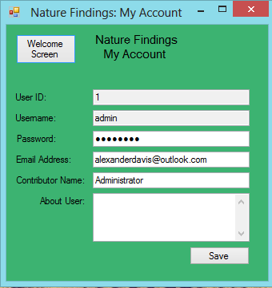
The My Account screen allows you to change your password, update information about yourself such as password reset email addresses and add a short paragraph describing yourself to other members on the system.
You are able to make multiple changes before clicking save. All changes will be put onto the system together and will not affect your finds.
Once you click save, the system will give you a confirmation that your details have been saved successfully.

Login
The login screen allows you to access your personal finds and search the knowledgebase. The account you must use to login to the system is the username and password given to you when you contact the system administrator requesting for an account (See Accounts Section).

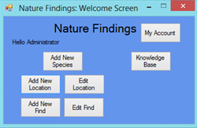
Create New
You can create 3 new items on the system provided that they haven’t already been created by another user. These include new Species, new Locations and new Finds.

Species
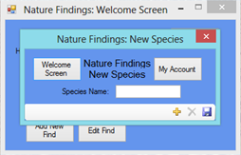
This is the New Species Screen. You are able to add species but not remove them. To remove a species form the system please contact the system administrator, details above. Before you can enter a new species into the system, you need to press the “add new” button in the bottom right of the screen.
Once you have entered the species name into the form, click the disc icon in the bottom right to add it to the system. The system will check for you if it already exists, if it does there should be an error message informing you; otherwise the system will say Species Saved.

Location
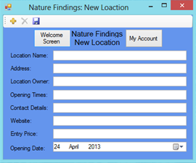
This is the New Location Screen. Just like the New Species screen, you are able to add locations but not remove them. To remove a location form the system please contact the system administrator, details above. Before you can enter a new location into the system, you need to press the “add new” button in the top left of the screen.
Once you have entered the location’s details into the form, click the disc icon in the bottom right to add it to the system. The system will check for you if it already exists, if it does there should be an error message informing you; otherwise the system will say Location Saved.

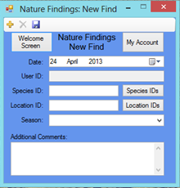
Find
This is the New Find screen. Just like the other add new screens you need to select the “Add New” button before you can enter any details into the system. All fields except the Additional comments field are required in this form; the program will remind you if you have not entered anything into the system. You do not need to enter your User ID as the system will automatically do this for you.

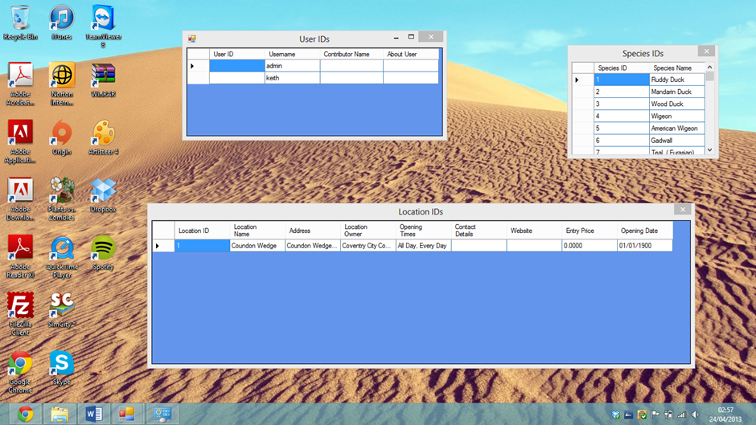

To enter a Species or Location into the form, you will need to find the Species and Location ID in the ID screens. These can be accessed by clicking the button next to the field.
Once you have entered in the details for your find, don’t forget to click the save button in the top left of the screen; the system will let you know if it has been saved correctly or not. If you have made an error, please go to the Edit Find screen in the system where you can also remove finds.

Edit Existing
As well as creating new locations and personal finds, you are also able to update them if an error has been made or details have changed.

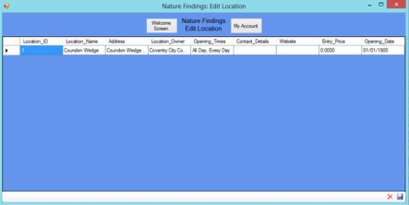
Location
The Edit Location Screen allows you to change details of existing locations in the system, you cannot add a new location to the system using this screen neither can you delete an existing location. Once the screen appears, you are able to immediately make changes to locations. You can make more than one change to more than one location at the same time. Don’t forget to click save once you have made all your changes.

Find
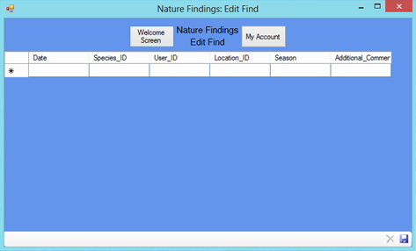
The Edit Find Screen allows you to change details of all your existing finds in the system, you cannot add a new find to the system using this screen. Once the screen appears, you are able to immediately make changes to locations. You can make more than one change to more than one location at the same time. You are also able to delete finds if you do not want them. Don’t forget to click save once you have made all your changes.

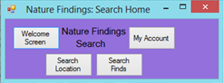
Knowledgebase
You are able to make two searches with the system, Location Search and Find Search. You can switch search type easily within each search screen.

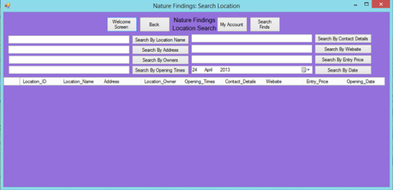
Location Search
The Location Search Screen allows you to look through the system for a specific location using the Location Name, Address, Owners, Opening Times, Contact Details, Website, Entry Price and Opening Date.
You are only able to search using one search criteria, e.g. Location Name OR Address.
If there are no results available, the system will inform you of this.

Find Search
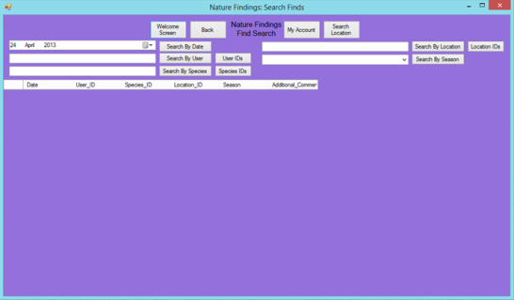
The Find Search Screen allows you to search for sightings by specific Species, Users, Locations, Dates and Seasons. Just like the Location Search Screen, you are only able to search using one of those criteria types.
If there are no results available, the system will inform you of this.

Admin Guide

Installation
To install the system onto your computer, download the files from https://www.creativelogiccoventry.co.uk/naturefindings. You will then need to unzip the file to a location where you can access it easily. You should have two files now. One database file and an application .exe file. Do not rename these files as the system will stop working and you may have to reinstall it.

Database Management
The database file can be edited by anyone to remove locations or species. The database can also be used to reset people’s passwords. The database has 4 tables within it. Species, Location, User and User_Species_Link. The Location and Species tables are self-explanatory; the User_Species_Link table holds all finds for anyone that uses the system, this table should not be touched outside of the system. The users table holds all user information and passwords. Administrators should use a default reset password if a user has forgotten their password.

Troubleshooting

Installation Issues

I cannot download the file, the link does not work

Possible Causes
You may not have a working internet connection to access the website.
The website may be down. If so, contact the developer: alexanderdavis@outlook.com for assistance.

I cannot save the file
You may not have enough disk space to save the files.

System Issues

I cannot log in and there is an error but I don’t understand it
You may not have the Access Database Engine. Try reinstalling it.

The system keeps crashing
Contact the developer: alexanderdavis@outlook.com

